VOLTFLEET AI: INTELLIGENT EV FLEET MANAGEMENT, PREDICTIVE BATTERY ANALYTICS & ROUTE OPTIMIZATION
PROJECT REPORT – PHASE I
Submitted by
MITHILESH S Register No.: 23UCS100
MATHIVANAN M Register No.: 23UCS099
KANAKALA NAGA VISHNU K Register No.: 23UCS079
NISHAN S Register No.: 23UCS108

Under the guidance of
MRS. P. NIRMALADEVI
in partial fulfillment of the requirements for the degree
of
BACHELOR OF TECHNOLOGY

DEPARTMENT OF COMPUTER SCIENCE AND ENGINEERING
SRI MANAKULA VINAYAGAR ENGINEERING COLLEGE
MADAGADIPET, PUDUCHERRY - 605107
OCTOBER 2026

AFFILIATED TO PONDICHERRY UNIVERSITY

DEPARTMENT OF COMPUTER SCIENCE AND ENGINEERING

BONAFIDE CERTIFICATE

This is to certify that the project work entitled “VOLTFLEET AI: INTELLIGENT EV FLEET MANAGEMENT, PREDICTIVE BATTERY ANALYTICS & ROUTE OPTIMIZATION” is a bonafide work done by MITHILESH S [REGISTER NO.: 23UCS100], MATHIVANAN M [REGISTER NO.: 23UCS099],KANAKALA NAGA VISHNU K[REGISTER NO.: 23UCS079], NISHAN S [REGISTER NO.: 23UCS108] in partial fulfillment of the requirement, for the award of B.Tech Degree in Computer Science and Engineering by Pondicherry University during the academic year 2026-2027.

PROJECT COORDINATOR PROJECT GUIDE HEAD OF THE DEPARTMENT
[Dr. N. Danapaquiame] [Mrs. P. Nirmaladevi] [Dr. N. Danapaquiame]

Submitted for the End Semester Practical Examination held on __________

Internal Examiner | External Examiner
[Mrs. P. Nirmaladevi]
Assistant Professor
Department of
Computer Science and Engineering

ACKNOWLEDGEMENT

We express our deepest gratitude and sincere appreciation to our project guide, MRS. P. NIRMALADEVI, whose constant guidance, invaluable technical insights, and enthusiastic encouragement enabled the successful completion of this project work. She has been an inspiring mentor to our team throughout the system design and implementation phases.

We also sincerely thank our Head of the Department, Dr. N. DANAPAQUIAME whose continuous encouragement and sufficient comments enabled us to complete our project report.

We thank all our Staff members who have been by our side always and helped us with our project. We also sincerely thank all the lab technicians for their help as in the course of our project development.

We would also like to extend our sincere gratitude and grateful thanks to our Director cum Principal Dr. V. S. K. VENKATACHALAPATHY for having extended the Research and Development facilities of the department.

We would like to express our faithful and grateful thanks to our Chairman and Managing Director Shri. M. DHANASEKARAN for his support.

We would like to thank our Secretary Dr. K. NARAYANASAMY for his constant support

We take immense pleasure in thanking our Treasurer Shri. D. RAJARAJAN and our Joint Secretary Shri. S. VELAYUDHAM for their great support.

We wish to thank our family members and friends for their constant encouragement, constructive criticisms and suggestions that has helped us in timely completion of this project.

Last but not the least, we would like to thank the ALMIGHTY for His grace and blessings over us throughout the project.

ABSTRACT
The rapid growth of Electric Vehicles (EVs) has created new challenges in commercial fleet management, particularly in battery health monitoring, driving range estimation, route planning, charging management, and driver performance evaluation. Conventional fleet management systems mainly depend on static vehicle information and basic tracking methods, which may not adequately consider important EV-specific factors such as battery State of Charge (SOC), State of Health (SOH), vehicle speed, ambient temperature, elevation, HVAC power consumption, and driving behavior. These limitations can lead to inaccurate range estimation, inefficient routing, increased charging costs, accelerated battery degradation, and reduced fleet operational efficiency.

This project presents VoltFleet AI, an intelligent full-stack EV fleet management platform designed to integrate Artificial Intelligence, Machine Learning, real-time telematics, battery analytics, and route optimization into a centralized system. The proposed platform uses vehicle telemetry data such as GPS coordinates, speed, battery SOC/SOH, cell voltage, inverter temperature, odometer, and elevation profiles to provide intelligent fleet monitoring and decision support. The system incorporates Machine Learning models including HistGradientBoosting Regression for dynamic driving range prediction and battery health analytics, along with Multiple Linear Regression for AI-based driver performance evaluation. The platform also integrates elevation-aware route planning and automated charging-stop recommendations to support energy-efficient fleet operations.

The proposed system consists of six major modules: Live Interactive Fleet Command Center, Role-Based Authentication and Secure Telematics Ingestion, Dynamic Multi-Stop Route Optimizer and Global Elevation Engine, ML-based Driver Performance Scoring, Physics-Informed ML Battery Range Predictor and Health Analytics, and Smart Charging Scheduler with Predictive Maintenance Planner. The fleet command center provides real-time visualization of vehicle positions, battery levels, vehicle status, and telemetry information, while the route optimizer considers terrain elevation and battery conditions for improved route planning.

LIST OF ABBREVIATIONS

ABBREVIATION | FULL FORM
AI | Artificial Intelligence
API | Application Programming Interface
CAN | Controller Area Network
CCS2 | Combined Charging System 2
DC | Direct Current
EV | Electric Vehicle
GPS | Global Positioning System
HVAC | Heating, Ventilation and Air Conditioning
IoT | Internet of Things
JSON | JavaScript Object Notation
JWT | JSON Web Token
KPI | Key Performance Indicator
ML | Machine Learning
RBAC | Role-Based Access Control
RUL | Remaining Useful Life
SHAP | SHapley Additive exPlanations
SOC | State of Charge
SOH | State of Health
IEEE | Institute of Electrical and Electronics Engineers
DOI | Digital Object Identifier

LIST OF FIGURES
Figure No. | Title | Page No.
1.1 | FLEET COMMAND CENTER | 53
1.2 | Fleet Monitor | 53
1.3 | Battery Analysis | 54
1.4 | Route Optimization | 54
1.5 | Charging Management | 55
1.6 | Reports | 55
5.1 | System Architecture | 34
5.2 | System Use Case Diagram | 34

TABLE OF CONTENTS
CHAPTER NO. |  | TITLE | PAGE NO.
 | ABSTRACT |  | iii
 | LIST OF TABLES |  | iv
 | LIST OF FIGURES |  | v
 | LIST OF ABBREVIATIONS |  | vi
1. | INTRODUCTION |  | 1
 | 1.1 | Electric Vehicle Fleet Management | 1
 | 1.2 | Artificial Intelligence and Machine Learning in EV Fleet Management | 2
 | 1.3 | Intelligent EV Battery and Range Analytics | 3
 | 1.4 | Motivation for the Project | 4
 | 1.5 | Problem Definition | 5
 | 1.6 | Scope of the Project | 6
2. | LITERATURE SURVEY |  | 9
 | 2.1 | Introduction | 9
 | 2.2 | Artificial Intelligence and Machine Learning in Electric Vehicle Fleet Management | 10
 | 2.3 | Electric Vehicle Battery Health and Range Analytics | 11
 | 2.4 | Route Optimization, Charging Management and Telematics | 12
 | 2.5 | Predictive Maintenance and Intelligent Fleet Monitoring | 13
 | 2.6 | Research Gap and Summary | 14
3. | EXISTING SYSTEM |  | 15
 | 3.1 | Introduction | 15
 | 3.2 | Existing EV Fleet Management Approach | 15
 | 3.3 | Limitations of Existing System | 16
 | 3.4 | Conventional System Workflow | 17
 | 3.5 | Drawbacks of Existing System | 17
 | 3.6 | Need for an Intelligent EV Fleet Management System | 18
4. | PROPOSED SYSTEM |  | 19
 | 4.1 | Introduction | 19
 | 4.2 | Proposed System Architecture | 20
 | 4.3 | Intelligent Fleet Monitoring and Telematics | 21
 | 4.4 | AI-Based Route, Battery and Driver Analytics | 22
 | 4.5 | Smart Charging and Predictive Maintenance | 23
 | 4.6 | Integrated Working and Advantages of the Proposed System | 24
5. | IMPLEMENTATION AND RESULTS |  | 26
 | 5.1 | Introduction | 26
 | 5.2 | Tools and Technologies Used | 27
 | 5.3 | Implementation Steps | 28
 | 5.4 | Machine Learning Model Implementation | 30
 | 5.5 | Module Integration and User Interface Implementation | 31
 | 5.6 | System Working and Implementation Flow | 32
 | 5.7 | System Architecture | 33
 | 5.8 | System Use Case Diagram | 34
6. | MODULES |  | 35
 | 6.1 | Module 1: Live Interactive Fleet Command Center | 35
 | 6.2 | Module 2: Role-Based Authentication & Secure Telematics Ingestion | 36
 | 6.3 | Module 3: Dynamic Multi-Stop Route Optimizer & Global Elevation Engine | 37
 | 6.4 | Module 4: ML AI Driver Performance Scoring | 38
 | 6.5 | Module 5: Physics-Informed ML Range Predictor & Health Analytics | 39
 | 6.6 | Module 6: Smart Charging Scheduler & Predictive Maintenance Planner | 40
 | 6.7 | Integrated Module Working | 42
7. | RESULTS AND PERFORMANCE EVALUATION |  | 43
 | 7.1 | Introduction | 43
 | 7.2 | Fleet Monitoring and Telematics Results | 44
 | 7.3 | Route Optimization Results | 45
 | 7.4 | Battery Range Prediction and Health Results | 45
 | 7.5 | Driver Performance Scoring Results | 46
 | 7.6 | Smart Charging and Predictive Maintenance Results | 46
 | 7.7 | Overall System Evaluation | 47
 | 7.8 | Performance Summary | 48
8. | CONCLUSION |  | 49
 | 8.1 | Conclusion | 49
 | 8.2 | Future Enhancements | 50
 | REFERENCES |  | 52

CHAPTER - 1

1. INTRODUCTION
Electric Vehicles (EVs) are increasingly being adopted for commercial transportation, logistics, delivery services, and fleet-based operations. The growing use of EVs has created a need for intelligent fleet management systems that can monitor vehicle performance, battery condition, charging status, driver behavior, and overall fleet operations. Unlike conventional vehicles, the performance of an EV depends strongly on factors such as battery State of Charge (SOC), State of Health (SOH), vehicle speed, ambient temperature, HVAC load, road elevation, and driving behavior. Therefore, basic vehicle tracking and static range estimation may not provide sufficient information for efficient EV fleet management.
Effective EV fleet management requires accurate driving range prediction, battery health monitoring, energy-aware route planning, driver performance analysis, smart charging, and predictive maintenance. Conventional routing systems may primarily consider distance or travel time without considering battery depletion, elevation gradients, regenerative braking, and charging requirements. Similarly, traditional fleet monitoring systems may use separate tools for vehicle tracking, maintenance, charging, and driver management, making it difficult for fleet managers to obtain a centralized view of fleet operations.
VoltFleet AI is proposed as a full-stack intelligent EV fleet management platform that integrates real-time telematics, Artificial Intelligence (AI), Machine Learning (ML), battery analytics, route optimization, driver performance evaluation, smart charging, and predictive maintenance. The system uses vehicle data such as GPS coordinates, speed, battery SOC/SOH, cell voltage, inverter temperature, odometer, and elevation profiles to provide intelligent fleet monitoring and decision support.
The proposed platform applies Machine Learning for dynamic EV range prediction and driver performance evaluation. The range prediction process considers parameters such as battery SOC, vehicle velocity, ambient temperature, elevation, and HVAC load. The system also analyzes driver-related parameters including regenerative braking, harsh deceleration, rapid throttle changes, overspeeding, and route adherence.
VoltFleet AI further provides a dynamic multi-stop route optimizer that considers terrain elevation and battery conditions while recommending suitable charging stops. A centralized Fleet Command Center provides real-time visualization of vehicle locations, battery levels, operational status, and telemetry information. The platform also includes battery degradation tracking, predictive maintenance alerts, and smart charging scheduling.

1.1. ELECTRIC VEHICLE FLEET MANAGEMENT
Electric Vehicles (EVs) are becoming an important part of modern transportation because of their potential to reduce dependence on conventional fuel and support more sustainable mobility. As the adoption of EVs increases in commercial transportation, organizations are increasingly using multiple electric vehicles for delivery, logistics, transportation, and other fleet-based operations. Managing a large number of EVs requires more than simple vehicle tracking because the performance of an electric vehicle is strongly influenced by battery condition, driving behavior, environmental conditions, route characteristics, and charging availability.
Traditional fleet management systems mainly focus on basic vehicle tracking, route monitoring, maintenance records, and driver information. However, EV fleets introduce additional requirements such as monitoring battery State of Charge (SOC), State of Health (SOH), energy consumption, charging requirements, and estimated driving range. A fleet manager must be able to determine whether a vehicle has sufficient battery capacity to complete its assigned route and identify when charging or maintenance is required.
The VoltFleet AI project is designed as an intelligent EV fleet management platform that combines real-time telematics, Artificial Intelligence (AI), Machine Learning (ML), battery analytics, route optimization, driver performance evaluation, and smart charging. The project aims to provide a centralized environment where fleet managers can monitor vehicle conditions and make data-driven operational decisions.
The proposed platform uses vehicle telemetry such as GPS coordinates, vehicle speed, battery SOC and SOH, cell voltage, inverter temperature, odometer information, and elevation profiles. These parameters provide useful information for understanding vehicle condition, energy consumption, and operational performance. The project specifically focuses on integrating these parameters into intelligent prediction and optimization mechanisms.

1.2. ARTIFICIAL INTELLIGENCE AND MACHINE LEARNING IN EV FLEET MANAGEMENT
Artificial Intelligence has become an important technology for developing intelligent transportation and fleet management applications. AI allows computer systems to analyze large amounts of vehicle data, identify patterns, generate predictions, and support operational decision-making. Machine Learning, as a major branch of AI, enables systems to learn relationships from historical data and use the learned patterns to make predictions for new vehicle conditions.
In EV fleet management, machine learning can be applied to several areas including driving range prediction, battery health estimation, driver performance analysis, predictive maintenance, energy consumption prediction, and charging optimization. Instead of relying only on fixed rules or simple average calculations, ML models can consider multiple vehicle and environmental parameters simultaneously.
The VoltFleet AI project uses HistGradientBoosting Regression for battery range prediction and health analytics. The model considers variables such as battery capacity, battery SOC, vehicle velocity, ambient temperature, HVAC power consumption, and route terrain elevation. This allows the system to estimate available driving range while considering operating conditions.
Machine Learning is also used for driver performance evaluation. The proposed system uses Multiple Linear Regression to analyze different driving and operational parameters. These include daily distance, average speed, harsh braking, rapid acceleration, end-of-day charge level, daily revenue, and maintenance-related factors. The resulting analysis is organized around safety, energy efficiency, battery care, and route compliance.
Therefore, the combination of AI, ML, and real-time telematics provides the foundation for transforming conventional fleet monitoring into an intelligent fleet management system.

1.3. INTELLIGENT EV BATTERY AND RANGE ANALYTICS
The battery is one of the most important components of an Electric Vehicle because it determines the available energy and significantly influences the vehicle's operating range. Two important battery parameters used in EV monitoring are State of Charge (SOC) and State of Health (SOH).

SOC represents the remaining battery charge available to the vehicle, while SOH represents the condition of the battery compared with its expected or original performance. Monitoring these parameters is important for determining whether an EV can safely complete its assigned journey and for identifying battery degradation over time.

A simple range estimation method based only on previous energy consumption may not accurately represent real-world driving conditions. Factors such as vehicle velocity, ambient temperature, HVAC usage, terrain elevation, and battery condition can influence energy consumption. The VoltFleet AI system therefore considers multiple variables when estimating the available driving range.

The proposed battery analytics module uses a HistGradientBoosting regression model to predict real-world driving range. It also monitors battery-related parameters such as cell voltage, internal impedance, and capacity degradation across charge-discharge cycles. Temperature monitoring is included to generate alerts when battery or inverter temperature exceeds defined thresholds.

The system also provides a What-If Range Simulator, which allows fleet managers to examine the expected range before assigning a vehicle to a particular mission. This can help identify potential range limitations before vehicle deployment.

1.4. MOTIVATION FOR THE PROJECT
The increasing adoption of EVs in commercial transportation creates a need for intelligent fleet management solutions that can handle the specific operational characteristics of electric vehicles. Conventional fleet systems may provide vehicle location and basic telemetry, but EV fleet operators require additional information about battery condition, expected range, charging requirements, energy consumption, and driver behavior.
One major motivation for VoltFleet AI is the problem of EV range uncertainty. Conventional static range estimation may not sufficiently account for factors such as elevation, ambient temperature, HVAC load, and vehicle operating conditions. These factors can cause the actual energy consumption of a vehicle to differ from a simple estimated value.
Another motivation is battery degradation. Frequent high-rate charging, unsuitable charging schedules, and demanding operating conditions can affect battery health and operating costs. Monitoring SOH and battery-related telemetry can provide useful information for fleet planning and maintenance.
Driver behavior is also important in an EV fleet. Acceleration, braking, speed, and regenerative braking can influence energy consumption and vehicle operation. The project therefore introduces AI-based driver performance evaluation covering safety, efficiency, battery care, and route compliance.
Route planning is another important motivation. Conventional route planning may primarily consider distance or travel time, whereas EV route planning needs to consider battery availability, terrain elevation, energy consumption, and charging requirements. VoltFleet AI addresses this requirement through a dynamic multi-stop route optimizer with elevation analysis and charging-stop recommendations.
The project is therefore motivated by the requirement for a centralized and intelligent platform that can combine vehicle monitoring, battery analytics, route planning, driver evaluation, charging management, and predictive maintenance.

1.5. PROBLEM DEFINITION
The major problem addressed by VoltFleet AI is the lack of an integrated intelligent system capable of managing the different operational requirements of an EV fleet.
The project identifies the following major problems:

1. EV Range Anxiety and Static Estimation
Conventional range estimation methods may depend on historical averages and may not sufficiently consider elevation, ambient temperature, HVAC usage, and other operational factors. This can result in differences between predicted and actual driving range.

2. Battery-Unaware Route Planning
Standard route planning systems may focus primarily on distance and travel time. For EV fleets, route planning also needs to consider battery SOC, energy consumption, elevation changes, regenerative braking, and charging requirements.

3. Lack of EV-Specific Driver Analytics
Traditional driver evaluation systems may not adequately consider EV-specific driving factors. Parameters such as regenerative braking, rapid acceleration, harsh braking, and battery-related driving behavior are important for evaluating EV driving performance.

4. Fragmented Fleet Management
Fleet managers may need to work with separate systems for GPS monitoring, maintenance records, charging management, driver information, and vehicle analytics. This separation can make it difficult to obtain a unified view of fleet operations.

1.6. SCOPE OF THE PROJECT
The scope of VoltFleet AI covers the development of an integrated platform for monitoring and managing electric vehicle fleets using AI, Machine Learning, real-time telemetry, and optimization techniques.
The major scope areas are:

1. Real-Time Fleet Monitoring
The system provides a centralized fleet command center for monitoring vehicle locations, operational status, battery levels, vehicle speed, and telemetry information. The proposed interface uses an interactive map-based visualization for fleet monitoring.

2. Battery Range Prediction
Machine Learning is used to estimate EV driving range based on parameters such as battery capacity, SOC, velocity, temperature, HVAC load, and elevation.

3. Battery Health Analytics
The system monitors battery-related information including SOH, cell voltage differences, temperature, impedance, and capacity degradation to support battery health analysis.

4. Dynamic Route Optimization
The system provides multi-stop route planning using geographical and elevation information. The route optimizer considers terrain-related energy consumption and can recommend charging stops based on projected battery levels.

5. AI Driver Performance Evaluation
The system analyzes driver-related telemetry and generates performance information based on safety, efficiency, battery care, and route compliance. Personalized coaching recommendations are also included.

6. Smart Charging and Predictive Maintenance
The system includes charging scheduling and maintenance planning to support efficient fleet operation. Charging can be coordinated with suitable electricity tariff periods, while predictive maintenance functionality is intended to identify maintenance requirements before failures occur.

7. Centralized Fleet Management
All major functions are brought together into a single platform, allowing fleet managers to access vehicle monitoring, battery analytics, route planning, driver analytics, charging, and maintenance information from a centralized environment.
Electric Vehicles (EVs) are reshaping modern commercial logistics, passenger transit, and last-mile delivery. Yet, transitioning from internal combustion fleets introduces severe operational hurdles. Fleet supervisors face unforgiving real-world constraints: fluctuating battery states, non-linear degradation, charging infrastructure bottlenecks, and terrain-induced range uncertainty.
HistGradientBoosting regression powers the core range prediction and battery health analytics in VoltFleet AI. Rather than relying on naive lookup tables, the model processes real-time telemetry inputs—including pack capacity, instantaneous SOC, vehicle velocity, ambient temperature, HVAC thermal load, and topographical elevation changes—to generate accurate driving range forecasts.
Driver evaluation is handled through Multiple Linear Regression, which analyzes continuous telemetry streams. Key performance indicators include distance covered, average velocity, harsh braking events, rapid accelerations, end-of-day battery retention, and trip-level revenue generation. These metrics are synthesized into four actionable pillars: Safety, Energy Discipline, Battery Care, and Route Compliance.
By fusing predictive machine learning models with live telematics, VoltFleet AI elevates commercial fleet management from passive vehicle tracking to proactive, data-driven intelligence.

Chapter – 2

Literature Survey

2.1 Introduction
Electric Vehicle (EV) technology has developed rapidly in recent years, resulting in increasing adoption of electric vehicles for personal transportation, logistics, delivery services, and commercial fleet operations. Along with this growth, fleet operators face new challenges related to battery energy management, driving range, charging infrastructure, vehicle health, route planning, and operational efficiency. Unlike conventional vehicles, the performance of an electric vehicle is strongly influenced by battery State of Charge (SOC), State of Health (SOH), driving behavior, ambient temperature, road elevation, HVAC usage, and charging conditions.

Recent research has therefore focused on applying Artificial Intelligence (AI), Machine Learning (ML), Internet of Things (IoT), telematics, optimization techniques, and data analytics to electric vehicle management. Machine learning models can be used to estimate remaining driving range and analyze driver behavior, while optimization techniques can support route planning and charging decisions. IoT and telematics provide continuous vehicle information that can be processed for real-time monitoring and predictive maintenance.

The literature reviewed for VoltFleet AI covers major research areas including EV range prediction, battery health estimation, dynamic route optimization, driver behavior analysis, smart charging, predictive maintenance, IoT-based telematics, explainable AI, and intelligent fleet dispatch. These research areas provide the technical foundation for developing an integrated intelligent EV fleet management platform.

2.2 Artificial Intelligence And Machine Learning In Electric Vehicle Fleet Management
Artificial Intelligence and Machine Learning have become important technologies for analyzing the large amount of data generated by modern electric vehicles. Vehicle sensors and telematics systems continuously generate information related to speed, location, battery condition, temperature, energy consumption, charging status, and driving behavior. Machine learning techniques can identify relationships within this information and use them to generate predictions and recommendations.
One major application of machine learning in EV management is remaining driving range prediction. Traditional range estimation methods typically depend on historical static averages and fixed lookup tables, which fail to capture rapid shifts in operating dynamics. Recent studies have investigated ensemble learning and tree-based models such as XGBoost, LightGBM, and Random Forest for dynamic range prediction under variable operating speeds, ambient temperatures, road gradients, and auxiliary HVAC loads [1], [8]. Although these models demonstrate marked accuracy improvements over static baselines, challenges remain in real-time edge integration and unifying elevation contours into dynamic route graphs.
Machine learning is also increasingly applied to driver performance profiling. EV-specific driving analytics must account for nuances in regenerative braking utilization, high-discharge acceleration profiles, aggressive deceleration, and overall energy discipline. Prior work has evaluated regression architectures and telemetry clustering models using high-frequency CAN-bus data streams to quantify driver efficiency and safety [7], [8].
VoltFleet AI uses HistGradientBoosting regression for battery range prediction and Multiple Linear Regression for driver performance scoring. The range prediction model considers battery capacity, SOC, velocity, ambient temperature, HVAC power, and terrain elevation. The driver scoring model evaluates operational and telemetry parameters to generate performance information across safety, efficiency, battery care, and route compliance.
Artificial Intelligence can therefore transform raw vehicle data into meaningful fleet intelligence. Instead of simply displaying sensor values, an intelligent fleet platform can estimate future range, identify inefficient driving patterns, and provide recommendations to fleet managers and drivers.

2.3 Electric Vehicle Battery Health And Range Analytics
Battery performance is one of the most important factors affecting electric vehicle operation. The usable energy available from a battery changes over time because of repeated charging and discharging cycles and different operating conditions. State of Charge represents the available battery energy, while State of Health provides information about the overall condition and degradation of the battery.
Battery degradation is fundamentally influenced by ambient thermal exposure, charging C-rates, cell depth of discharge (DoD), internal impedance growth, and cumulative cycling stress [2], [3]. Consequently, tracking State of Charge (SOC) in isolation is inadequate for long-term commercial fleet management. Continual State of Health (SOH) tracking is essential to anticipate accelerated capacity fade and schedule proactive battery refurbishments.
In response to these degradation phenomena, recent research has explored physics-informed machine learning (PIML) methodologies for battery health and Remaining Useful Life (RUL) forecasting [2], [6]. By coupling electrochemical domain dynamics with data-driven regressors, these frameworks reliably estimate capacity retention and cell impedance trends [3], [9]. Nevertheless, balancing computational complexity with the requirements of real-time onboard telemetry remains an active research frontier.
Range prediction and battery health are closely connected. As battery health decreases, the usable capacity of the battery may also decrease, affecting the expected driving range. Therefore, an intelligent EV fleet system needs to consider both current battery SOC and long-term battery condition.
VoltFleet AI incorporates a Physics-Informed ML Battery Range Predictor and Health Analytics module. The system uses HistGradientBoosting to estimate available range and considers battery capacity, SOC, velocity, ambient temperature, HVAC power, and terrain elevation. Battery health analysis considers cell delta-voltage, internal impedance, and estimated capacity fade. Temperature monitoring is also incorporated to identify abnormal thermal conditions.
The combination of range prediction and battery health monitoring provides fleet managers with a better understanding of whether a vehicle is suitable for a particular journey. It can also support maintenance planning and reduce unexpected operational interruptions.

2.4 Route Optimization, Charging Management And Telematics
Route planning for electric vehicles is different from conventional route planning because the available battery energy must be considered along with distance and travel time. A route containing significant elevation changes can require more energy than a flat route, while downhill sections can provide regenerative braking opportunities. Charging stations must also be considered when the available battery energy is insufficient for the complete journey.
Dynamic eco-routing formulations focus on determining energy-optimal paths and charging stops across road networks [8]. The literature highlights optimization approaches based on Mixed-Integer Linear Programming (MILP), dynamic programming, and heuristic graph search variants such as constrained A* [4], [8]. While effective at minimizing charging transit delays and grid impacts, many formulations rely on static charging wait times and simplified topological representations.
Elevation-aware routing is particularly important for EVs because climbing increases energy consumption while descending can provide regenerative recovery. Research on multi-objective EV route planning has therefore incorporated gravitational potential energy, rolling resistance, aerodynamic effects, and regenerative braking into energy models.
Depot charging coordination constitutes another critical dimension of fleet operations. When multiple commercial EVs return simultaneously, charging schedules must be dynamically synchronized against fleet departure commitments, grid transformer peak loads, and Time-of-Use (ToU) electricity tariffs. Advanced multistep charging profiles and predictive two-stage smart charging algorithms have been proposed to mitigate cell stress, safeguard battery health, and lower energy procurement costs [4], [5].
IoT and telematics provide the real-time information required for these operations. Vehicle systems can continuously provide GPS coordinates, speed, battery SOC and SOH, cell voltage, temperature, odometer readings, and charging information. Research has investigated MQTT, WebSockets, microservices, and edge-based processing for real-time commercial fleet monitoring.
VoltFleet AI combines these concepts through its Dynamic Multi-Stop Route Optimizer and Global Elevation Engine and Smart Charging Scheduler. The route optimizer uses global location and elevation information to evaluate routes and identify suitable charging stops, while the charging scheduler coordinates charging according to operational requirements and off-peak electricity periods.

2.5 Predictive Maintenance And Intelligent Fleet Monitoring
Vehicle reliability is essential for commercial fleet operations because unexpected vehicle failures can cause delays, additional costs, and reduced fleet availability. Traditional preventive maintenance generally follows fixed service intervals. Predictive maintenance uses actual vehicle condition and historical telemetry to identify possible failures before they become critical.
Electric vehicles generate a large amount of operational information through sensors and vehicle control systems. Motor temperature, inverter temperature, cell voltage, battery temperature, odometer readings, charging information, and other telemetry can be analyzed to identify abnormal conditions.
Prior literature also encompasses telemetry-driven diagnostic frameworks that monitor traction motor vibrations, inverter thermal gradients, and cell delta-voltages to flag early signs of powertrain or pack failure [7]. These cloud-based architectures prove that sensor-level anomaly detection can avert catastrophic downtime, provided high-frequency telemetry streams are processed systematically.
Explainable AI can further improve intelligent fleet monitoring by helping users understand why an AI model generated a particular result. Research has investigated SHAP and feature-attribution techniques for explaining driver safety scores and eco-driving recommendations. Such techniques can make AI-generated results more understandable to fleet operators and drivers.
VoltFleet AI integrates predictive maintenance with real-time fleet monitoring. Its maintenance module can monitor vehicle mileage and sensor anomalies and generate maintenance requirements. The Fleet Command Center provides a centralized interface for viewing vehicle positions, operational states, battery information, and telemetry diagnostics.
This integration allows maintenance information to become part of the overall fleet management process instead of being maintained as an independent activity.

2.6 Research Gap And Summary
The literature demonstrates significant development in individual areas of electric vehicle management. Machine learning has been applied to range prediction and driver behavior analysis, while physics-informed approaches have been investigated for battery health estimation. Optimization methods have been developed for route planning and charging scheduling, and IoT-based telematics systems provide real-time vehicle information. Predictive maintenance and explainable AI further extend the capabilities of intelligent fleet management.
However, many of these research areas are addressed independently. A range prediction model may not directly interact with route planning, while a route optimization system may not continuously consider battery health and driver behavior. Similarly, charging management, maintenance monitoring, and telematics may operate as separate systems. This creates a need for an integrated platform capable of combining vehicle monitoring, predictive analytics, route optimization, driver evaluation, charging management, and maintenance planning.
VoltFleet AI addresses this requirement by integrating these capabilities into a single intelligent EV fleet management platform. The proposed system combines real-time telematics, AI-based range prediction, battery health analytics, dynamic route optimization, AI driver performance scoring, smart charging, and predictive maintenance. The six modules defined for the project are designed to work together so that vehicle information can support operational decisions across the fleet.
The literature survey therefore establishes the theoretical and technological foundation for the proposed VoltFleet AI system. The concepts discussed in this chapter are further applied in the following chapters for designing the system architecture, existing system analysis, proposed system, implementation, testing, and evaluation.

Chapter – 3

Existing System

3.1 Introduction
Electric Vehicle fleet management systems are designed to monitor vehicles, track their locations, manage drivers, and support basic fleet operations. Conventional fleet management platforms generally use GPS tracking, vehicle information, maintenance records, and basic telematics to provide fleet managers with an overview of vehicle activities. These systems are useful for monitoring the operational status of vehicles, but they may not provide the advanced intelligence required for efficient electric vehicle fleet management.
The operation of an EV depends strongly on battery condition, energy consumption, charging availability, driving behavior, and road conditions. Therefore, an effective EV fleet management system needs to consider parameters such as battery State of Charge (SOC), State of Health (SOH), elevation, temperature, HVAC load, regenerative braking, and vehicle speed. The existing approaches described in the project identify several limitations in conventional fleet management, particularly in range estimation, route planning, driver analysis, software integration, and charging management.

3.2 Existing Ev Fleet Management Approach
Existing fleet management platforms primarily provide vehicle tracking and operational monitoring. GPS-based systems can display the current location of vehicles and provide information such as distance travelled and vehicle status. Telematics systems can additionally collect information from vehicle sensors and transmit it to a centralized platform.
Although these systems provide useful operational information, they generally focus on monitoring rather than prediction. A fleet manager may be able to identify the current location of a vehicle and its battery level, but the system may not accurately determine how road elevation, temperature, HVAC usage, and driving behavior will affect the vehicle's future energy consumption.
The existing approach also commonly separates fleet functions into different systems. GPS tracking, maintenance management, charging management, driver monitoring, and operational records may be maintained independently. This fragmented approach can make it difficult for fleet managers to obtain a complete view of vehicle performance.

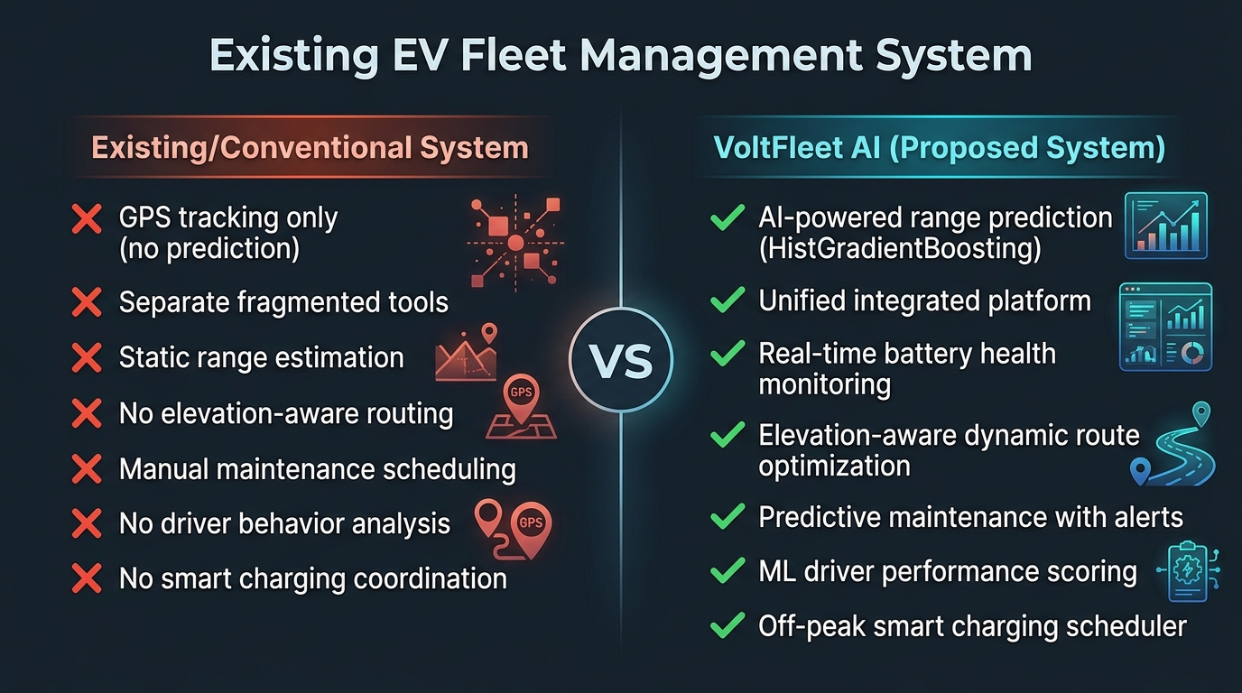
Figure 4: Comparison – Existing System vs Proposed VoltFleet AI System

3.3 Limitations Of Existing System
One major limitation of conventional EV range estimation is its dependence on static or historical averages. Such estimation methods may not adequately consider changes in topographic elevation, ambient temperature, cabin climate control, payload, and driving conditions. As a result, the estimated range may differ from the actual range experienced during a journey.
Another limitation is that conventional route planning generally concentrates on distance or travel time. Standard routing systems may not consider battery SOC depletion, elevation gradients, regenerative braking recovery, or charging requirements while selecting a route. This can result in routes that are operationally difficult for EVs, particularly for long-distance commercial transportation.
Existing driver monitoring systems may also focus on conventional vehicle parameters. Such systems may not provide sufficient analysis of EV-specific characteristics such as regenerative braking utilization, battery thermal stress, and high-discharge acceleration. This limits the ability of fleet managers to understand the relationship between driver behavior and EV energy consumption.
Charging management is another challenge. When charging is not coordinated with vehicle schedules and electricity tariffs, fleet operators may have difficulty controlling charging costs and charger availability. Frequent high-power charging and uncontrolled charging schedules can also create additional operational challenges.
The existing fleet environment can therefore become fragmented when GPS tracking, maintenance records, charging management, driver information, and battery analytics are handled through separate tools. This creates additional operational effort and can introduce delays in accessing important fleet information.

3.4 Conventional System Workflow
The general operation of a conventional fleet management system can be represented as:
Vehicle → GPS/Telematics → Data Collection → Fleet Database → Monitoring Dashboard → Fleet Manager
In this approach, vehicle information is collected and displayed to the fleet manager. The manager can monitor vehicle location and operational status and manually make decisions related to routing, charging, and maintenance.
However, the system does not necessarily provide continuous predictive intelligence. Range estimation, route planning, charging decisions, driver evaluation, and maintenance activities may require separate processes or manual intervention.
The lack of integration between these activities makes it difficult to establish a continuous relationship between vehicle condition and fleet decisions. For example, a vehicle with reduced battery health may require a different route or charging plan, but a conventional monitoring system may only display its current battery level.

3.5 Drawbacks Of Existing System
The existing approach has limitations in providing dynamic EV-specific intelligence. Static range estimation can result in inaccurate expectations about the remaining driving range. Route planning without battery awareness can fail to account for elevation, energy consumption, and charging requirements. Conventional driver analytics may not sufficiently consider EV-specific driving characteristics.
The fragmentation of fleet management functions is another major limitation. Fleet managers may need to switch between different tools for vehicle tracking, maintenance, charging, and driver management. This increases operational complexity and can make real-time decision-making more difficult.
Another concern is battery degradation and charging cost management. Uncontrolled charging during high-tariff periods can increase operating expenses, while inappropriate charging behavior can negatively affect long-term battery performance. The project identifies these issues as important limitations that need to be addressed through an integrated intelligent platform.

3.6 Need For An Intelligent Ev Fleet Management System
The limitations of existing fleet management approaches demonstrate the need for a system that can combine monitoring, prediction, optimization, and decision support. An intelligent EV fleet management platform should not only display the current vehicle condition but should also analyze available information and provide useful predictions.
A suitable system needs to consider vehicle telemetry, battery SOC and SOH, route elevation, environmental conditions, driving behavior, charging requirements, and maintenance information. These parameters can be processed using machine learning and optimization techniques to provide more comprehensive fleet intelligence.
The proposed VoltFleet AI system is designed to address these limitations through an integrated platform. It combines real-time telematics tracking, physics-informed machine learning range estimation, dynamic route optimization, AI-based driver performance scoring, battery health analytics, smart charging, and predictive maintenance.
The transition from conventional monitoring to intelligent prediction and optimization forms the basis for the proposed system discussed in the next chapter.

CHAPTER – 4
Proposed System
4.1 Introduction
The proposed system, VoltFleet AI, is an intelligent Electric Vehicle fleet management platform designed to address the limitations identified in conventional EV fleet management systems. The system combines real-time vehicle monitoring, secure telematics, Machine Learning, battery analytics, route optimization, driver performance evaluation, smart charging, and predictive maintenance into a unified platform.
The primary purpose of the proposed system is to provide fleet managers with a centralized environment for monitoring and managing electric vehicles. Instead of depending only on static vehicle information or separate software applications, VoltFleet AI continuously processes vehicle and operational data to generate useful predictions and recommendations. The system uses information such as GPS coordinates, vehicle speed, battery State of Charge (SOC), State of Health (SOH), cell voltage, inverter temperature, odometer readings, and elevation profiles.
The proposed platform is designed around six major functional areas. These include intelligent fleet monitoring and secure telematics, dynamic route optimization, AI-based driver performance analysis, battery range prediction and health analytics, smart charging, and predictive maintenance. The integration of these functions enables the system to connect vehicle monitoring with prediction and decision-making.

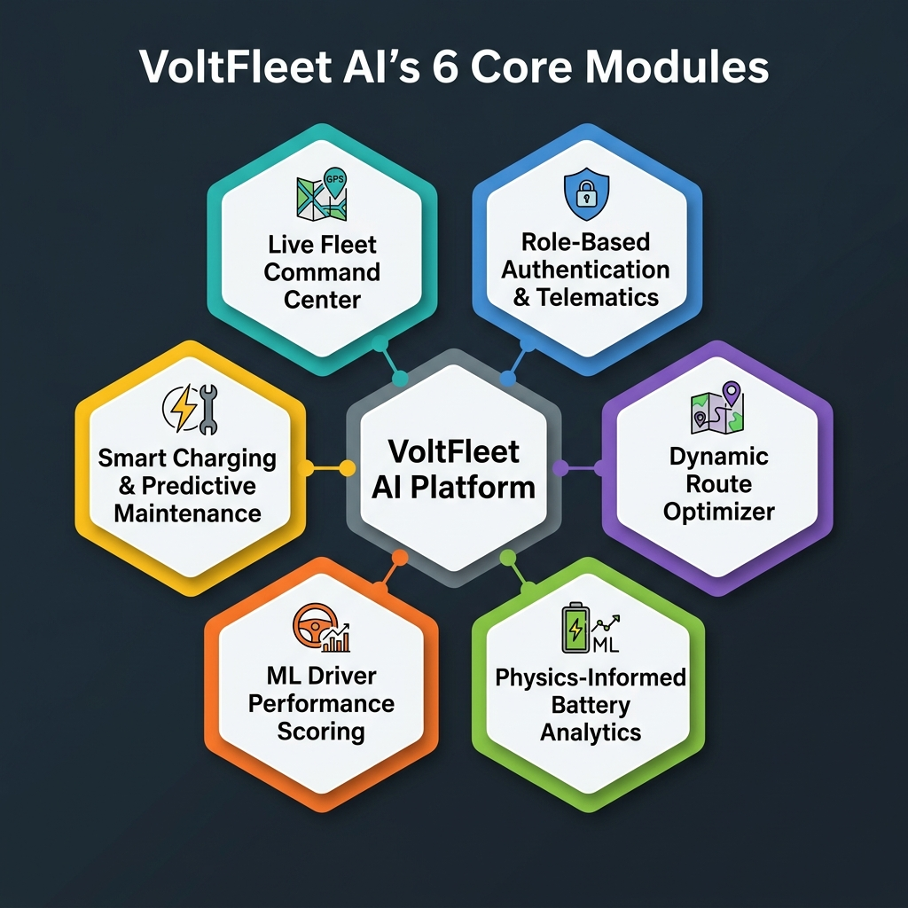
Figure 1: VoltFleet AI – Overview of 6 Core Integrated Modules
The system is particularly focused on commercial EV operations where vehicle availability, energy efficiency, charging time, battery condition, and driver performance directly affect fleet operations. By combining real-time information with predictive analytics, VoltFleet AI aims to provide better visibility of the complete fleet and support timely operational decisions.

4.2 Proposed System Architecture
The architecture of VoltFleet AI follows a layered approach in which vehicle data is collected, securely transferred, processed, analyzed, and presented to the fleet manager. The architecture connects the physical EV fleet with the software and Machine Learning components of the proposed platform.

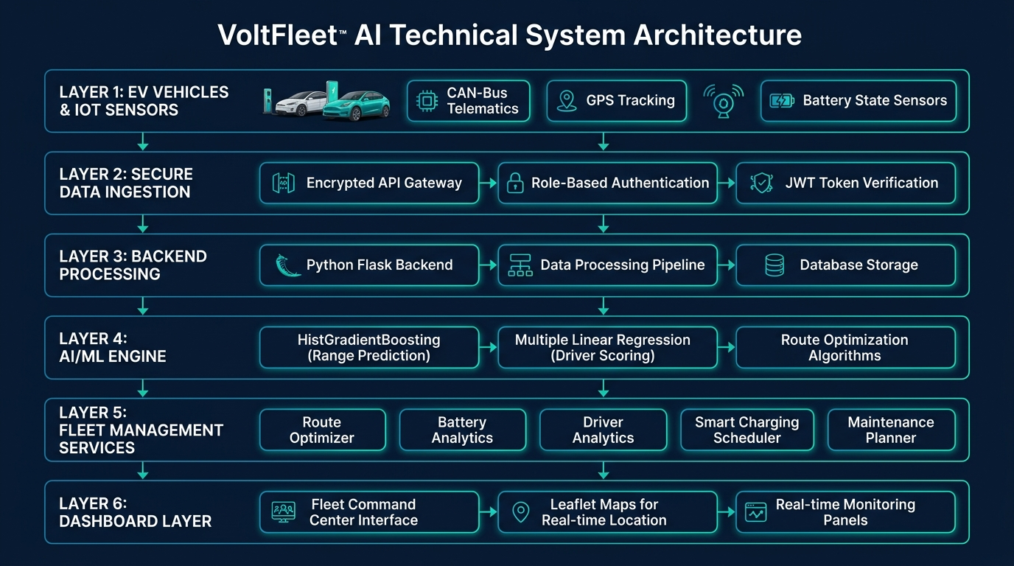
Figure 2: VoltFleet AI System Architecture – Layered Data Flow
The general architecture can be represented as:
EV Vehicles → IoT/CAN-Bus Telematics → Secure Data Ingestion → Backend Processing → AI/ML and Optimization → Fleet Management Services → Dashboard
The first layer consists of electric vehicles and their associated telemetry sources. Vehicle sensors generate information related to location, speed, battery condition, temperature, odometer readings, and other operational parameters. The project specifically identifies GPS coordinates, speed, battery SOC/SOH, cell voltage, inverter temperature, odometer, elevation profiles, and global city coordinates as important data used by the platform.
The next layer is responsible for secure telematics ingestion. The incoming information is received by the backend and processed before being stored or supplied to analytical services. The proposed system uses FastAPI, SQLAlchemy, Pydantic, and database technologies for backend processing. Role-based authentication is used to separate fleet-manager and driver access.
The processing layer prepares the collected information for different analytical operations. Battery and vehicle parameters are provided to the range prediction and health analytics module. Driver-related telemetry is provided to the driver scoring model, while location and elevation information are used by the route optimization engine.
The application layer contains the intelligent services of the platform. Machine Learning models generate predictions, route optimization evaluates energy-aware routes, and charging and maintenance services use vehicle information to generate operational recommendations.
Finally, the dashboard layer presents the processed information to users. The Fleet Command Center provides an interactive map and fleet-level information, allowing managers to observe the current state of vehicles and access analytical results from a centralized interface.
4.3 Intelligent Fleet Monitoring and Telematics
The Intelligent Fleet Monitoring and Telematics component provides the real-time connection between the vehicles and the VoltFleet AI platform. Its purpose is to collect operational information from the vehicles and make that information available to fleet managers and other system modules.
The Live Interactive Fleet Command Center acts as the main monitoring interface. It uses Leaflet and OpenStreetMap to display vehicle positions on an interactive geographical map. The vehicle markers provide information regarding operational state, battery SOC, battery SOH, current velocity, and inverter temperature. Vehicles can be monitored according to states such as active, in transit, charging, or idle.
The system also provides vehicle selection and filtering capabilities. This allows a fleet manager to focus on a particular vehicle or group of vehicles rather than viewing the entire fleet at the same time. Fleet-level information can also be presented through KPI information, giving managers an overview of mileage, battery health, active vehicles, and energy efficiency.
The telematics ingestion component continuously receives information from vehicle sensors. The proposed system considers GPS coordinates, speed, cell voltage, temperature, SOC, SOH, and odometer readings as important telemetry information. This data becomes the foundation for other analytical functions in the platform.
Security is incorporated into the telematics architecture through role-based authentication. Fleet managers can access fleet dispatch, maintenance, and analytics functions, while drivers receive access to information relevant to their assigned vehicles and activities. The proposed authentication architecture uses bcrypt password hashing and signed JSON Web Tokens for secure access.
Real-time telematics also allows the system to connect monitoring with prediction. For example, changes in vehicle temperature can contribute to health monitoring, changes in SOC can influence range prediction, and changes in speed or braking behavior can contribute to driver performance analysis.

4.4 AI-Based Route, Battery and Driver Analytics
The AI-Based Route, Battery and Driver Analytics component combines three major intelligent functions of VoltFleet AI: energy-aware route optimization, battery range prediction and health analysis, and driver performance evaluation.
The Dynamic Multi-Stop Route Optimizer is designed specifically for electric vehicle operations. Conventional route planning generally considers distance and travel time, whereas the proposed system additionally considers battery energy requirements and road elevation. The system uses global city information and route data to construct journeys between different locations.
Elevation is important because an uphill section requires additional energy while a downhill section can provide opportunities for regenerative braking. The proposed elevation engine therefore incorporates terrain information into route analysis. The route summary can provide information about elevation gain, estimated travel time, energy consumption, and expected arrival SOC.

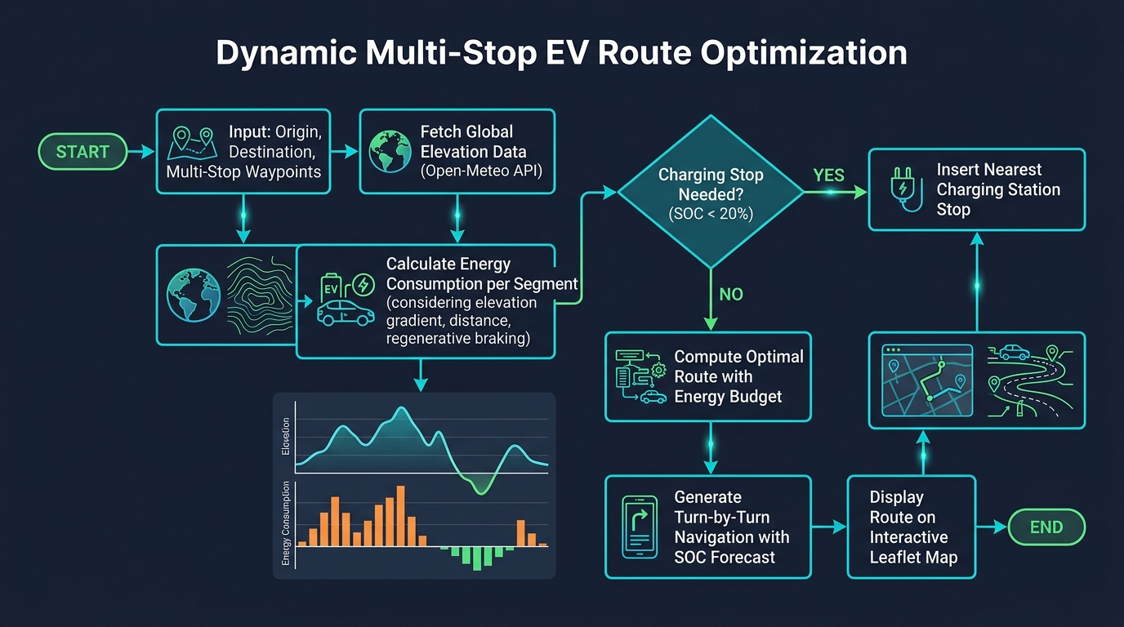
Figure 5: Dynamic Multi-Stop EV Route Optimization Flowchart
The system can also identify situations where the predicted battery level is insufficient for the remaining route. When the projected SOC falls below the configured safe threshold, the route optimizer can recommend the insertion of a fast-charging stop. This allows charging requirements to be considered during route planning rather than after the route has already been selected.
Battery range prediction is handled by the Physics-Informed ML Battery Range Predictor and Health Analytics module. The proposed system uses HistGradientBoosting regression to estimate available driving range. The model uses parameters such as battery capacity, SOC, velocity, ambient temperature, HVAC power, and route terrain elevation.

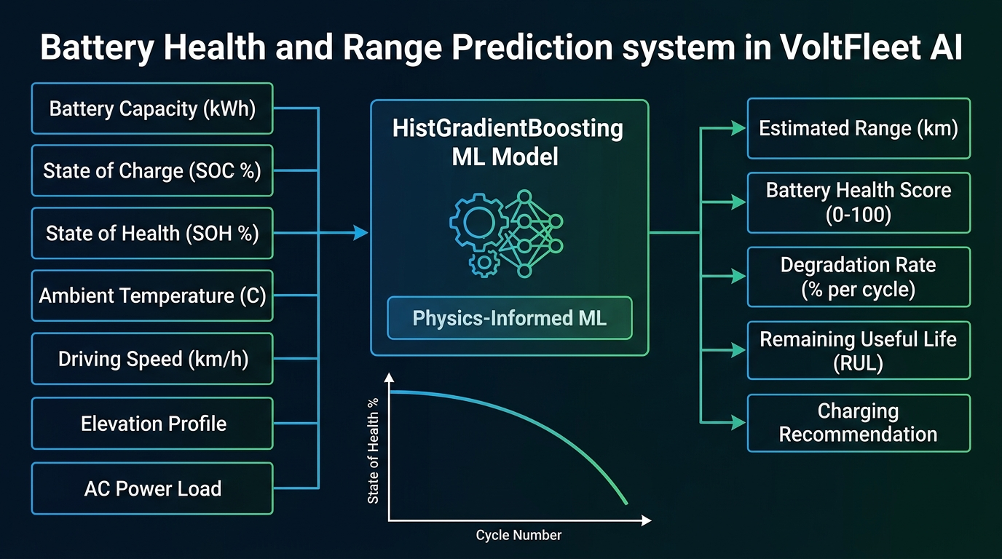
Figure 6: Battery Health & Range Prediction – ML Pipeline Diagram
The range prediction process allows the fleet manager to understand whether a vehicle is suitable for a planned journey. The What-If Range Simulator can also be used to examine how different operating conditions may affect the expected range before vehicle deployment.
Battery health is analyzed along with range prediction. The system monitors cell delta-voltage, internal impedance, and estimated capacity fade over charge-discharge cycles. Temperature information is also monitored to identify abnormal thermal conditions. This provides a connection between the current battery condition and the expected future performance of the vehicle.
The driver analytics component uses Multiple Linear Regression to evaluate driver performance. The model considers information such as daily distance, average speed, harsh braking, rapid acceleration, end-of-day charge percentage, daily revenue, and maintenance impact. The resulting performance analysis is organized around Safety, Efficiency, Battery Care, and Route Compliance.

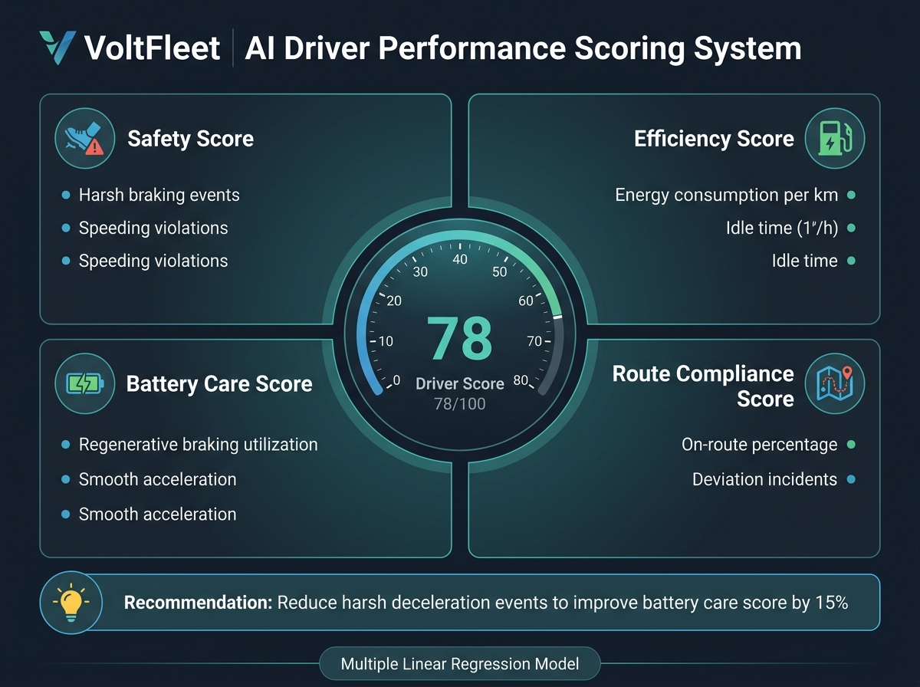
Figure 7: AI Driver Performance Scoring System – Score Breakdown
The system can use these results to generate personalized coaching recommendations. For example, driving patterns involving frequent harsh deceleration can be identified and associated with recommendations for smoother driving. This makes the driver module more useful than simply recording driver activity.
The integration of route, battery, and driver analytics provides a complete operational view. The route optimizer determines how the vehicle should travel, the range predictor estimates whether the vehicle can complete the journey, and the driver analytics evaluates how the vehicle is being operated.

4.5 Smart Charging and Predictive Maintenance
The Smart Charging and Predictive Maintenance component is responsible for managing the vehicle's charging requirements and supporting long-term fleet reliability. Charging and maintenance are important aspects of EV fleet management because both directly influence vehicle availability and operating cost.
The Smart Charging Scheduler coordinates charging activities according to vehicle requirements and available charging periods. Instead of charging every vehicle immediately after it reaches the depot, the system can schedule charging according to battery condition, target departure time, charger availability, and electricity tariff periods.
The project proposes off-peak tariff optimization, where charging activities can be scheduled during lower-cost electricity windows. The charging system also considers different charging-port and connector requirements. The project specifies support for charging configurations including CCS2, Type 2, and DC fast charging options.

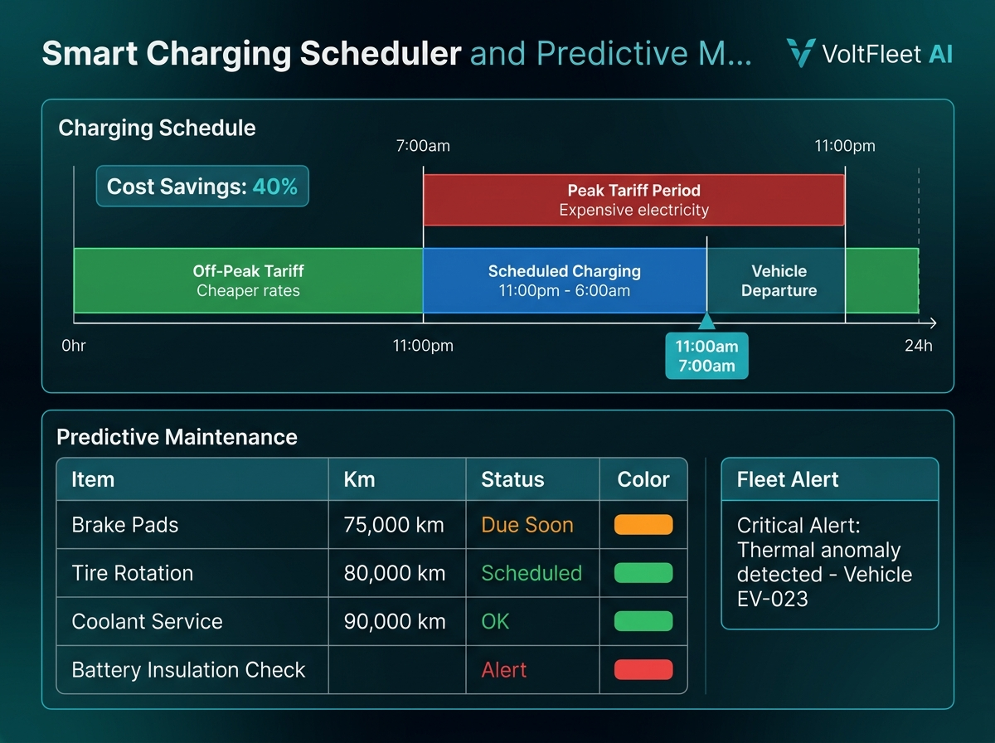
Figure 8: Smart Charging Scheduler & Predictive Maintenance Dashboard
Smart charging is particularly useful in fleet environments where multiple vehicles may return to the depot at similar times. Without coordinated scheduling, several vehicles may compete for charging infrastructure. The proposed system provides a structured approach to assigning charging resources while maintaining operational requirements.
The predictive maintenance component works alongside the charging system. It monitors vehicle usage and sensor information to identify maintenance requirements. Odometer milestones can be used to schedule routine servicing, while sensor anomalies can be used to identify conditions requiring additional inspection.
The proposed system includes maintenance activities related to brake pads, tire rotation, coolant servicing, and battery insulation. The automated fleet alert center categorizes telemetry and maintenance notifications so that important conditions can be brought to the attention of the fleet manager.
Predictive maintenance provides an important connection between real-time monitoring and long-term fleet management. Instead of waiting until a vehicle develops a serious problem, the system can use available information to identify maintenance requirements earlier.
The combination of smart charging and predictive maintenance helps maintain vehicle availability. Charging ensures that vehicles have sufficient energy for future operations, while maintenance planning helps ensure that vehicles remain in suitable operating condition.

4.6 Integrated Working and Advantages of the Proposed System
The major feature of VoltFleet AI is the integration of its different components into a single fleet management environment. Each module performs a specific function, but the information generated by one module can support the operation of other modules.
The complete process begins when vehicle telemetry is collected from the EV. GPS, speed, battery, temperature, and other sensor information are transmitted to the backend through the telematics ingestion layer. The backend processes this information and makes it available to the appropriate services.
When a vehicle is assigned to a journey, the route optimizer evaluates the selected route. Elevation information is analyzed to understand the effect of terrain on energy consumption. The battery range prediction model then estimates the expected range based on the vehicle's battery condition and operating conditions. If the estimated range is insufficient, the route optimizer can recommend an appropriate charging stop.
Once the vehicle begins its journey, real-time telemetry is continuously received by the system. The Fleet Command Center updates the vehicle's position and operational information. Battery condition can be monitored through the health analytics module, while driver telemetry is analyzed to determine performance.
The charging scheduler can subsequently coordinate charging based on the vehicle's battery requirements and available charging periods. At the same time, the maintenance module can use mileage and telemetry information to identify upcoming service requirements.
The complete working of the proposed system can therefore be represented as:

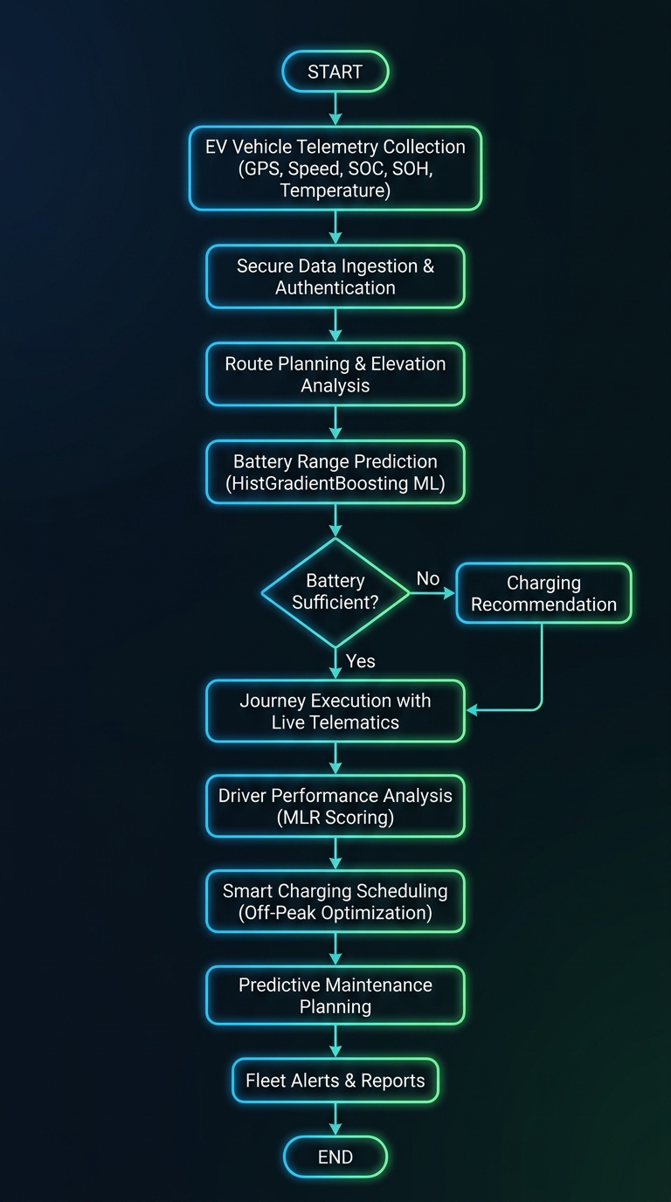
Figure 3: VoltFleet AI Complete End-to-End Workflow Flowchart
Vehicle Data → Secure Telematics → Data Processing → AI/ML Analysis → Route and Energy Decision → Real-Time Monitoring → Charging and Maintenance → Fleet Dashboard
The integrated architecture provides several operational advantages. It provides centralized fleet visibility through the Fleet Command Center and combines vehicle monitoring with predictive analytics requirements with route planning.

Chapter – 5

Implementation And Results

5.1 Introduction
The system implementation phase focuses on transforming the proposed VoltFleet AI architecture into a functional intelligent electric vehicle fleet management platform. The implementation integrates the fleet monitoring interface, secure telematics ingestion, route optimization, Machine Learning models, battery analytics, driver performance analysis, smart charging, and predictive maintenance into a unified software system.
The implementation follows a modular architecture so that each major function can be developed, tested, and integrated independently. The frontend provides the user interface for fleet managers and drivers, while the backend manages vehicle information, telemetry data, authentication, Machine Learning services, route calculations, charging schedules, and maintenance information.
The implementation process begins with the preparation of vehicle and telemetry data. The collected information includes GPS coordinates, vehicle speed, battery SOC and SOH, cell voltage, inverter temperature, odometer readings, and elevation information. This data is processed by the backend before being supplied to the appropriate analytical modules. The project identifies FastAPI as the backend framework and uses technologies such as SQLAlchemy and Pydantic for backend data management and validation.
The Machine Learning implementation contains two major predictive components. HistGradientBoosting is used for EV range prediction, while Multiple Linear Regression is used for driver performance scoring. The range model considers battery capacity, SOC, velocity, ambient temperature, HVAC power, and terrain elevation. The driver scoring model evaluates driving-related parameters and produces performance information across safety, efficiency, battery care, and route compliance.
The implementation also connects the analytical modules with the interactive dashboard. This allows the predictions and recommendations generated by the backend to be presented to users through maps, charts, KPI indicators, vehicle information panels, alerts, and fleet management interfaces.

5.2 Tools and Technologies Used
The development of VoltFleet AI requires a combination of frontend technologies, backend frameworks, Machine Learning libraries, mapping technologies, database tools, and visualization libraries. The technologies are selected according to the requirements of real-time fleet monitoring, geospatial visualization, data processing, predictive analytics, and web-based fleet management.
React is used as the primary frontend framework for developing the interactive user interface. The frontend provides the Fleet Command Center, vehicle monitoring interface, route planning screens, driver analytics dashboard, battery analytics interface, charging information, and maintenance alerts. React supports a component-based architecture, allowing different sections of the fleet management platform to be developed as reusable components.
Leaflet.js is used for interactive geographical visualization. The system uses Leaflet with OpenStreetMap to display vehicle locations and route information on an interactive world map. Vehicle markers can represent operational states such as active, in transit, charging, and idle. The Fleet Command Center also presents telemetry information through interactive vehicle popups.
FastAPI is used as the backend framework for implementing the application programming interfaces and Machine Learning services. It manages requests from the frontend, validates incoming data, communicates with the database, and provides prediction and fleet-management services.
Python is used for backend processing and Machine Learning development. Python provides access to libraries required for numerical computation, data manipulation, Machine Learning, database communication, and API development.
Scikit-learn is used for implementing the Machine Learning models. The project uses HistGradientBoostingRegressor for battery range prediction and LinearRegression for driver performance scoring. NumPy and Pandas support numerical operations and data preparation, while Joblib can be used for storing and loading trained Machine Learning models.
SQLAlchemy is used as the Object Relational Mapping layer for database interaction. Pydantic is used for data validation and structured request and response handling. The proposed telematics architecture supports SQLite or PostgreSQL for storing vehicle and operational information.
Open-Meteo Elevation API is used as part of the route optimization process to obtain elevation information. Haversine geometry is used for geographical distance calculations, while Recharts is used to display route elevation profiles, analytical graphs, and other visual representations.
The overall technology stack therefore connects frontend visualization, backend processing, geospatial services, database management, and Machine Learning into one integrated platform.

5.3 Implementation Steps
The implementation process begins with the creation of the project environment and configuration of the frontend and backend applications. The frontend and backend are maintained as separate logical components so that the user interface and server-side processing can be developed independently. The backend exposes APIs that are accessed by the frontend to obtain fleet information, predictions, routes, driver scores, charging information, and maintenance alerts.
The first major implementation step is the development of the vehicle and telematics data layer. Vehicle information such as vehicle identification, location, speed, SOC, SOH, temperature, odometer, and telemetry information is structured into appropriate database records. Incoming information is validated before being processed by the backend. The project proposes an asynchronous telematics ingestion pipeline for handling vehicle sensor payloads such as GPS, speed, cell voltage, and temperature.
The next step is implementing authentication and access control. The system separates fleet-manager operations from driver operations using Role-Based Access Control. Fleet managers can access dispatch, analytics, maintenance, and fleet information, while drivers can access information related to their assigned vehicles, routes, earnings, inspections, and performance. Passwords are protected using bcrypt hashing and authentication is supported using signed JWT tokens.
The Fleet Command Center is then implemented using React and Leaflet. The map displays vehicle positions using geographical coordinates received from the backend. Each vehicle marker can provide information about its operational state, battery SOC, SOH, velocity, and inverter temperature. Filtering functionality allows the fleet manager to focus on particular vehicle models or operational states. The dashboard also contains KPI information representing fleet-level operational conditions.
The route optimization module is implemented by combining geographical coordinates, route information, vehicle battery information, and elevation data. The system uses the Open-Meteo Elevation API to obtain terrain information and applies geographical distance calculations to evaluate routes. The elevation engine calculates the effect of climbing and downhill sections on vehicle energy requirements. When the projected SOC falls below the defined threshold, the system can insert a charging waypoint into the route.
The battery range prediction module is implemented using HistGradientBoosting regression. The model receives important operating variables such as battery capacity, SOC, velocity, ambient temperature, HVAC power, and terrain elevation. These parameters allow the system to estimate the effective driving range under the current operating conditions. The What-If Range Simulator can then be used to examine how changes in vehicle conditions affect the expected range.
The driver performance module is implemented using Multiple Linear Regression. The model processes variables including daily distance, average speed, harsh braking, rapid acceleration, end-of-day charge percentage, daily revenue, and maintenance impact. The generated analysis is organized into Safety, Efficiency, Battery Care, and Route Compliance. Personalized coaching recommendations can then be generated based on the identified driving patterns.
The charging module is implemented to coordinate vehicle charging based on battery requirements, charging availability, and suitable charging periods. The project specifically proposes automated off-peak charging scheduling and charging-port allocation. The predictive maintenance module is connected to vehicle mileage and telemetry information so that maintenance requirements and abnormal conditions can be displayed through the fleet alert system.
Finally, all modules are integrated with the Fleet Command Center. The frontend communicates with the backend through APIs, while the backend connects the database, Machine Learning models, route services, charging scheduler, and maintenance services. This creates a continuous flow from vehicle data collection to analysis and visualization.

5.4 Machine Learning Model Implementation
Machine Learning is an important part of VoltFleet AI because the system is designed not only to display vehicle information but also to generate predictions and analytical insights. Two major Machine Learning models are implemented for this purpose: HistGradientBoosting for battery range prediction and Multiple Linear Regression for driver performance scoring.
The battery range prediction model is implemented using HistGradientBoostingRegressor from Scikit-learn. The model is designed to estimate the available driving range of an EV under different operating conditions. The input variables include battery capacity, current SOC, vehicle velocity, ambient temperature, HVAC power consumption, and route elevation. These variables represent both vehicle and environmental factors that can affect energy consumption.
During implementation, the input data is organized into feature variables and the corresponding range values are used as the target variable. The data is prepared and supplied to the regression model for training. After training, the model can receive new vehicle conditions and estimate the expected range. The trained model can be stored and loaded by the backend when a prediction request is received.

The range model is also connected with the route optimization module. A predicted range is not treated as an isolated value. Instead, it is compared with the energy requirement of the planned route. If the available range is insufficient, the route optimizer can recommend a charging stop. This creates a connection between Machine Learning prediction and route planning.
The second Machine Learning model is Multiple Linear Regression for driver performance scoring. This model transforms raw telematics information into a structured driver performance assessment. The input features include daily distance, average speed, harsh braking events, rapid acceleration events, end-of-day charge, daily revenue, and maintenance impact.
The driver performance results are organized into four major areas. Safety considers driving events such as harsh braking and acceleration. Efficiency considers energy-related driving behavior. Battery Care considers behavior that can affect battery usage and thermal conditions. Route Compliance considers adherence to the planned route.
The resulting driver score can be displayed through charts and performance indicators. The system can also provide personalized coaching recommendations. For example, a driver showing repeated harsh deceleration behavior may receive guidance related to smoother braking. This transforms the Machine Learning output into actionable information rather than displaying only a numerical score.
The implementation therefore uses Machine Learning as a decision-support mechanism. The models process vehicle and driver data and provide information that can be used by fleet managers for route planning, vehicle assignment, driver coaching, and operational monitoring.
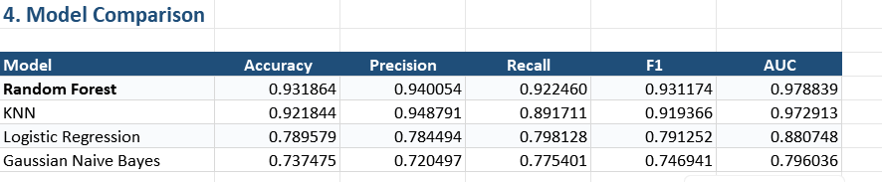

5.5 Module Integration and User Interface Implementation
The final stage of implementation is the integration of all individual modules into a single user-facing application. The integration is necessary because fleet managers need to access vehicle information, route information, battery predictions, driver analysis, charging status, and maintenance information without switching between multiple independent applications.
The Fleet Command Center acts as the central interface of the system. The Leaflet-based map provides geographical information while the surrounding dashboard components present vehicle and fleet KPIs. The project describes the Fleet Command Center as the centralized operational interface for visualizing vehicle positions, velocities, battery levels, and telemetry diagnostics.
The route planning interface allows the user to select an origin, destination, and intermediate locations. The route engine processes the selected locations and retrieves elevation information. The resulting route is displayed geographically, while the analytical section presents information such as elevation gain, estimated travel time, energy consumption, and expected arrival SOC.
The battery analytics interface presents the predicted driving range and battery health information. The What-If Range Simulator provides an interactive method for examining possible changes in range under different conditions. Battery health information can include cell voltage differences, internal impedance, capacity fade, and temperature-related warnings.
The driver dashboard presents the performance analysis generated by the driver scoring model. The four performance areas can be represented using charts and indicators. The interface can also display coaching recommendations generated from the driver's telemetry patterns.
The charging and maintenance interface provides information about charging requirements, scheduled charging activities, and maintenance requirements. Off-peak charging schedules can be displayed along with charging status, while maintenance alerts can identify upcoming or abnormal vehicle conditions.
The use of visualization is important because fleet management involves a large quantity of continuously changing information. Maps, KPI cards, charts, vehicle status indicators, and alert components allow complex telemetry information to be presented in a form that can be understood more easily by fleet operators.

5.6 System Working and Implementation Flow
After all modules are implemented, VoltFleet AI operates as an integrated sequence of data collection, processing, prediction, decision-making, and visualization.
The complete implementation flow begins with the electric vehicle. Vehicle sensors and CAN-bus/IoT telematics generate information about GPS location, speed, battery SOC and SOH, temperature, voltage, and odometer readings. This information is transmitted to the secure backend ingestion layer.
The backend validates and processes the incoming information before storing it in the database. The processed information is then distributed to the appropriate analytical services. Battery-related information is supplied to the range and health analytics module, driving information is supplied to the driver scoring module, and location and elevation information is supplied to the route optimizer.
For a new journey, the route optimizer calculates the selected route and evaluates the terrain. The battery prediction model estimates the available range using the current vehicle and environmental conditions. The predicted range is compared with the expected energy requirement of the route. If a charging requirement is identified, the system can recommend a suitable charging waypoint.
During vehicle operation, telemetry information continues to update the Fleet Command Center. The vehicle's location, speed, SOC, SOH, and temperature can be monitored through the dashboard. Driver behavior is simultaneously evaluated by the driver analytics module.
After the journey, charging requirements and maintenance information are updated. The charging scheduler can organize the next charging activity, while the maintenance module can identify service requirements based on vehicle usage and telemetry conditions.

The overall implementation can therefore be represented as:
EV Sensors and CAN-Bus → Secure Telematics Ingestion → Database and Data Processing → AI/ML Analysis → Route and Battery Decision → Fleet Monitoring → Driver Analysis → Smart Charging → Predictive Maintenance → Dashboard
This integrated implementation allows VoltFleet AI to operate as a complete intelligent fleet management platform rather than as a collection of independent applications. The project specifically combines real-time telematics, ML range estimation, dynamic route optimization, driver scoring, and predictive maintenance within the same platform.
The implementation also supports the project's intended operational objectives of improving fleet visibility, reducing range uncertainty, supporting battery health management, improving driver behavior, coordinating charging, and assisting maintenance planning. The example workflow provided in the project demonstrates how route planning, range prediction, charging-stop insertion, live telemetry, driver scoring, and maintenance can work together during a single vehicle mission.

5.7 SYSTEM ARCHITECTURE
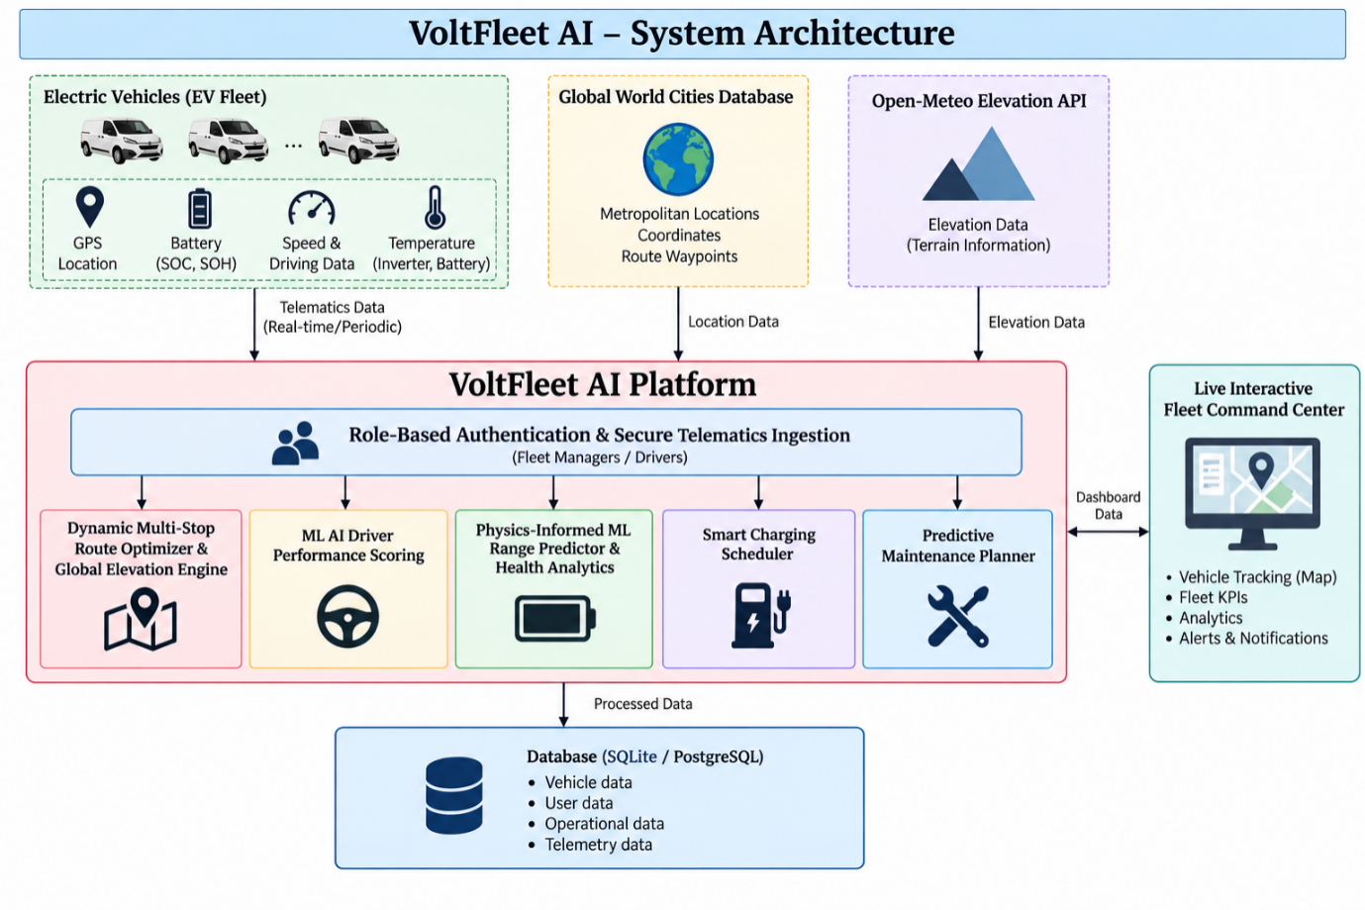
5.8 SYSTEM USE CASE DIAGRAM
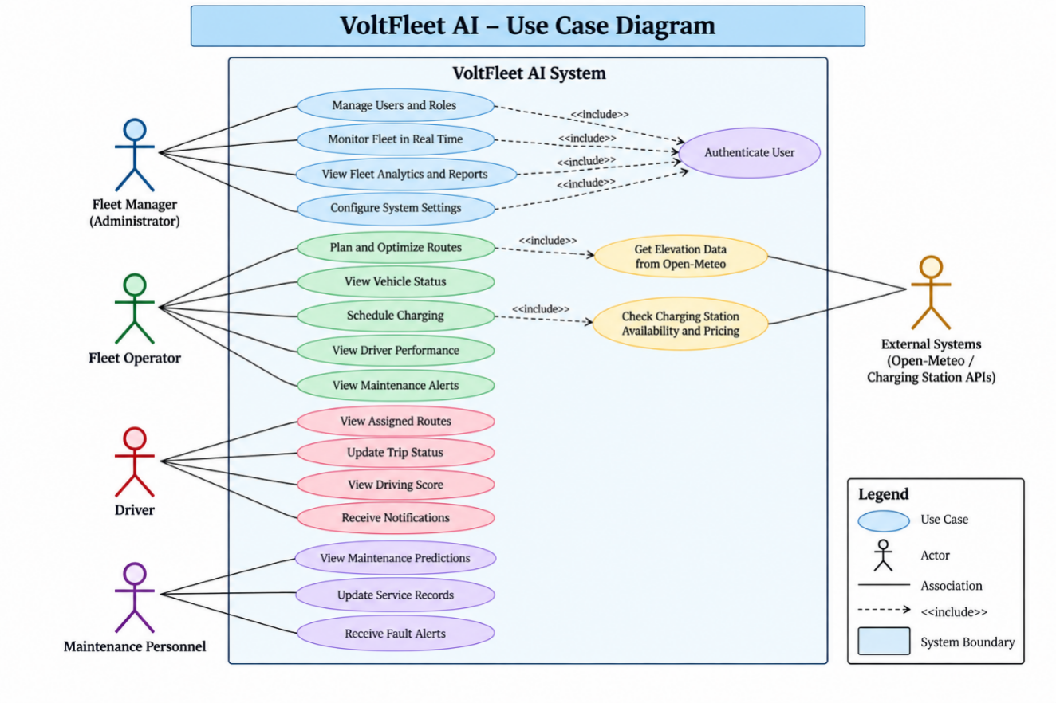
CHAPTER – 6
MODULES
The VoltFleet AI architecture is structured into six major operational modules that collectively deliver real-time telematics visualization, predictive battery analytics, elevation-aware routing, and automated charging management. These six modules form the core functional foundation of the proposed platform, engineered to operate seamlessly as an integrated decision-support ecosystem.
6.1 MODULE 1 : Live Interactive Fleet Command Center
The Live Interactive Fleet Command Center is the centralized operational interface of VoltFleet AI. It provides fleet managers with a real-time view of vehicles, their geographical positions, battery conditions, operating states, and important telemetry information. The module replaces conventional static fleet monitoring with an interactive geospatial dashboard.
The module uses Leaflet.js and OpenStreetMap to display vehicles on a global interactive map. Each vehicle is represented using a map marker that provides information about the current vehicle state. The supported operational states include Active, In Transit, Charging, and Idle. The marker information can also display the current battery State of Charge (SOC), State of Health (SOH), vehicle velocity, and inverter temperature.
The Fleet Vehicle Selector and Filter Strip enables dispatchers to isolate individual assets or filter vehicles based on operational status, hub location, or vehicle model. The platform is configured to support diverse commercial electric models, including the Tata Punch EV, Curvv EV, MG ZS EV, and Mahindra BE 6, providing unified oversight across heterogeneous fleet compositions.
The module also provides a Dynamic Fleet KPI Strip. This component aggregates important fleet-level information such as total fleet mileage, average battery health index, active deployed vehicles, and fleet-wide energy efficiency. These indicators allow the fleet manager to understand the overall operating condition without inspecting every vehicle individually.
The map interface is designed using a dark-mode, high-contrast visualization approach. OpenStreetMap provides the geographical map data, while Leaflet provides the interactive map functionality. The module is implemented using React, TanStack Router, Leaflet.js, Tailwind CSS, FastAPI, SQLAlchemy, and OpenStreetMap.
6.2 MODULE 2 :Role-Based Authentication & Secure Telematics Ingestion
The Role-Based Authentication and Secure Telematics Ingestion module provides the security and data-ingestion foundation of VoltFleet AI. Its purpose is to ensure that only authorized users can access specific fleet operations while allowing vehicle telemetry to be received and processed securely.
The system enforces strict Role-Based Access Control (RBAC), segregating functionality between two principal user classes: Fleet Managers and Commercial Drivers. Fleet managers are provisioned with enterprise-wide dispatch consoles, predictive maintenance planners, and analytics dashboards, whereas commercial drivers access assigned route turn-by-turn guidance, shift revenue logs, pre-trip digital inspection checklists, and individualized safety scorecards.
Authentication security is implemented using bcrypt password hashing and JSON Web Tokens. Password hashing protects stored user credentials, while JWT-based authentication provides secure access to protected application resources. Configurable token expiry and token renewal mechanisms can be used to maintain controlled user sessions.
The telematics ingestion component is responsible for receiving vehicle sensor information. The system is designed to handle high-throughput sensor payloads including GPS coordinates, vehicle speed, cell voltage, and temperature. The incoming information is processed through the backend and maintained with transactional integrity using database technologies such as SQLite or PostgreSQL.
The module also provides a dedicated Driver Portal. Through this portal, operators can review their assigned EV specifications, daily trip earnings, upcoming maintenance bookings, and personalized safety scores.
The backend implementation uses FastAPI with Python 3.11. PyJWT is used for JSON Web Token processing, Passlib with bcrypt supports password security, SQLAlchemy provides database interaction, and Pydantic provides structured data validation. SQLite or PostgreSQL can be used as the database layer.
This module therefore performs two important functions: protecting fleet information through controlled authentication and providing the secure data pathway through which vehicle telemetry enters the VoltFleet AI platform.
6.3 MODULE 3:Dynamic Multi-Stop Route Optimizer & Global Elevation Engine
The Dynamic Multi-Stop Route Optimizer and Global Elevation Engine is the navigation intelligence module of VoltFleet AI. It is designed specifically for electric vehicle fleet operations by considering not only geographical distance but also elevation, energy consumption, battery SOC, and charging requirements.
The module supports route planning across worldwide cities using a Global World Cities Database. The database provides metropolitan locations, geographical coordinates, and route waypoints. The system allows the dispatcher to select an origin, destination, and intermediate locations to construct a multi-stop commercial route.
One of the main features of the module is Digital Elevation Modeling. Elevation information is incorporated into the route analysis to determine the effect of terrain on vehicle energy consumption. Uphill sections introduce additional energy requirements, while downhill sections can provide opportunities for regenerative braking and energy recovery.
The route engine continuously calculates cumulative battery consumption along candidate waypoints. Whenever the projected battery SOC dips below the 20% safety threshold, the optimization algorithm automatically introduces a fast-charging stop. By prioritizing 150 kW DC fast-charging infrastructure, the system prevents mission abandonment and maintains battery operating reserves without incurring excessive dwell times.
The module also provides an Interactive Route Summary and Elevation Profile Chart. The dispatcher can view information such as cumulative gradient climb, estimated transit time, total energy consumption, and expected arrival SOC. This allows the user to understand the energy implications of the planned journey before dispatching the vehicle.

The route optimization process can be represented as:
Origin and Destination → Route Generation → Elevation Analysis → Energy Estimation → SOC Evaluation → Charging Stop Insertion → Final Route
The module uses Leaflet.js for geographical visualization, Open-Meteo Elevation API for elevation information, Haversine geometry for distance calculations, Recharts AreaChart for elevation visualization, and FastAPI for backend processing.
This module connects navigation with battery intelligence, making route planning an EV-specific process rather than a simple distance-based navigation operation.
6.4 MODULE 4 : ML AI Driver Performance Scoring
The ML AI Driver Performance Scoring module converts raw vehicle and driver telemetry into a structured evaluation of driving performance. The purpose of the module is to identify driving patterns that affect safety, energy efficiency, battery usage, and route adherence.
The module uses a trained Multiple Linear Regression model to evaluate driver performance. The model considers several input parameters including daily distance, average speed, harsh braking count, rapid acceleration instances, end-of-day charge percentage, daily revenue, and maintenance impact.
The generated performance analysis is organized into four major pillars: Safety, Efficiency, Battery Care, and Route Compliance. The Safety Index focuses on driving incidents and potentially unsafe driving events. Energy Efficiency considers vehicle energy consumption and driving efficiency. Battery Care considers factors related to battery preservation, thermal conditions, and SOC management. Route Compliance measures adherence to the assigned route.
The system provides a Four-Pillar Performance Radar to visually represent these performance dimensions. This allows the fleet manager to understand the strengths and areas requiring improvement for individual drivers.
Another important feature is Personalized AI Coaching Recommendations. The system can generate recommendations based on observed driving behavior. For example, repeated harsh deceleration can result in guidance related to smoother braking, while unsuitable highway speeds can lead to recommendations intended to reduce thermal stress and improve energy efficiency.
The module also provides an Interactive Multi-Dimensional Telemetry Stream. It can compare real-time speed in km/h, energy efficiency percentage, and motor power draw in kW. These values can be represented through graphical telemetry streams and operator-specific visualizations.
The implementation uses Scikit-learn LinearRegression, Pandas, NumPy, Recharts Dual-Line visualization, and the FastAPI Machine Learning pipeline.
The overall working of this module can be represented as:
Driver Telemetry → Data Processing → Feature Extraction → Linear Regression → Performance Analysis → Four-Pillar Score → AI Coaching
This module makes driver analysis an EV-specific process by considering driving behavior that directly affects energy consumption and battery operation.
6.5 MODULE 5: Physics-Informed ML Range Predictor & Health Analytics
The Physics-Informed ML Range Predictor and Health Analytics module is the core battery intelligence component of VoltFleet AI. Its purpose is to estimate the practical driving range of an electric vehicle and monitor the long-term health and operating condition of its battery.
The module uses a HistGradientBoosting regression model to forecast real-world available driving range. Instead of relying on a simple fixed range value, the model considers multiple vehicle and environmental parameters that influence energy consumption.
The range prediction model uses battery capacity, current SOC, vehicle velocity, ambient temperature, HVAC power draw, and route terrain elevation as major input features. Ambient temperature is considered across the specified operating range of approximately -10°C to 50°C. The inclusion of HVAC load and terrain elevation allows the system to account for operating conditions that can influence the expected driving range.
The module includes an Interactive What-If Range Simulator. Fleet dispatchers can use this component to examine the expected range before assigning a vehicle to a mission. Different operating conditions can be evaluated to determine whether a planned journey is feasible. If a potential range deficit is identified, the system can provide a visual warning.
The module also performs Battery State of Health analytics. It tracks parameters such as cell delta-voltage, internal impedance growth, and estimated capacity fade across charge-discharge cycles. These measurements provide information about changes in battery condition over time.
Thermal telemetry monitoring constitutes an essential safeguard within the battery analytics suite. Both inverter temperature and pack temperatures are continuously tracked in real time. Operating temperatures exceeding 45°C trigger immediate thermal stress warnings and governor advisories, preventing thermal runaway and preserving cell electrode integrity.
The module can therefore be represented as:
Battery and Vehicle Inputs → Data Processing → HistGradientBoosting Model → Range Prediction → SOH Analytics → Thermal Monitoring → Alerts
The technology stack includes Scikit-learn HistGradientBoostingRegressor, NumPy, Joblib, Recharts RadialBar, and FastAPI.
This module is directly connected to the route optimization module. The predicted range can be compared with the energy requirement of a planned route, allowing the system to identify potential range deficits and support charging-stop decisions.
6.6 MODULE 6: Smart Charging Scheduler & Predictive Maintenance Planner
The Smart Charging Scheduler and Predictive Maintenance Planner module manages two important aspects of EV fleet operation: charging coordination and vehicle maintenance. Its objective is to optimize fleet operating costs while maintaining vehicle availability and supporting long-term vehicle reliability.
The Smart Charging Scheduler optimizes depot charging events against Time-of-Use (ToU) electricity tariffs, vehicle turnaround windows, and depot transformer capacity limits. The scheduling engine prioritizes overnight off-peak tariff periods (23:00–06:00), capitalizing on lower electricity rates to drive charging cost reductions of up to 35% compared to uncontrolled plug-in charging.
The module also incorporates an automated Charging Port Allocation system. It matches returning fleet vehicles to available depot chargers based on energy deficit, required turnaround urgency, and hardware connector compatibility, accommodating CCS2, Type 2 AC, and high-output 50 kW–150 kW DC fast chargers.
The predictive maintenance component monitors vehicle usage and telemetry information to identify maintenance requirements. Odometer milestones can be used to schedule preventive maintenance, while sensor anomalies can be used to identify conditions that require inspection.
The system can automatically generate maintenance requirements for components and services such as brake pads, tire rotation, coolant flushing, and battery insulation inspection. This reduces dependence on manual maintenance tracking and helps fleet managers organize service activities according to vehicle condition and usage.
The module also includes an Automated Fleet Alerts Center. Alerts are categorized according to severity. Critical alerts can represent thermal or voltage faults, High alerts can represent overdue service conditions, and Moderate alerts can represent less urgent operational notifications. The alert workflow helps fleet managers identify which issues require immediate attention.
The module can be represented as:
Vehicle Status → Charging Requirement → Tariff Analysis → Charging Allocation → Scheduled Charging
and
Vehicle Telemetry → Odometer/Sensor Analysis → Maintenance Prediction → Service Ticket → Fleet Alert

The proposed technology stack includes a Python datetime scheduler, SQLAlchemy, Tailwind CSS for the interface, Recharts Timeline for visualization, and FastAPI for backend services.
The integration of charging and maintenance in the same module allows the system to address both immediate energy requirements and longer-term fleet maintenance planning.

6.7 Integrated Module Working
The six modules of VoltFleet AI are designed to operate together rather than as independent applications. Each module performs a specific task while exchanging information with other modules.
The Live Interactive Fleet Command Center provides the main operational interface. The Role-Based Authentication and Secure Telematics Ingestion module controls user access and receives vehicle telemetry. The Dynamic Multi-Stop Route Optimizer uses geographical and elevation information to create energy-aware routes. The ML AI Driver Performance Scoring module evaluates driver behavior. The Physics-Informed ML Range Predictor and Health Analytics module estimates available range and monitors battery condition. Finally, the Smart Charging Scheduler and Predictive Maintenance Planner coordinates charging and maintenance activities.
The integrated working can be represented as:
EV Vehicle → Telematics Ingestion → Fleet Monitoring → Battery/Range Analysis → Route Optimization → Driver Analysis → Smart Charging → Predictive Maintenance → Fleet Dashboard
For example, when a vehicle is assigned to a long-distance route, the Route Optimizer first determines the route and analyzes elevation. The Battery Range Predictor then estimates the expected available range using SOC, velocity, temperature, HVAC load, and elevation. If the predicted range is insufficient, the Route Optimizer can recommend a charging stop.
During the journey, telemetry is continuously received through the secure ingestion layer and displayed through the Fleet Command Center. Driver-related telemetry is supplied to the Driver Performance Scoring module, while battery and temperature information is supplied to the Battery Health Analytics module.
After or during the trip, the Smart Charging Scheduler can determine an appropriate charging period, while the Predictive Maintenance Planner can identify upcoming maintenance requirements. All important information and alerts are then made available through the Fleet Command Center.
CHAPTER – 7
RESULTS AND PERFORMANCE EVALUATION
7.1 INTRODUCTION
The results and performance evaluation phase is used to examine the working of the VoltFleet AI system and determine whether the implemented modules perform their intended functions. The evaluation focuses on the major capabilities of the proposed platform, including real-time fleet monitoring, secure telematics ingestion, dynamic route optimization, EV range prediction, driver performance scoring, battery health monitoring, smart charging, and predictive maintenance.
The evaluation is carried out by providing vehicle, battery, route, elevation, and driver-related information to the respective modules and observing the generated outputs. The results are presented through the Fleet Command Center, route visualization, range prediction interface, driver analytics dashboard, charging scheduler, and maintenance alert system.
To validate the end-to-end operational capabilities of VoltFleet AI, a comprehensive commercial transit scenario was evaluated using a Tata Curvv EV (55 kWh battery pack) traversing a 585 km commercial corridor between Berlin and Munich. This benchmark scenario demonstrates the unified integration of real-time telemetry streaming, elevation modeling, dynamic charging insertion, and driver scoring under realistic transit conditions.
7.2 Fleet Monitoring And Telematics Results
The Fleet Command Center provides the primary visualization of the EV fleet. The implemented interface displays vehicles on an interactive Leaflet and OpenStreetMap map and provides information regarding vehicle location and operational status.
The system represents vehicle states such as Active, In Transit, Charging, and Idle. Vehicle telemetry information including SOC, SOH, velocity, and inverter temperature can be displayed through interactive vehicle markers. This allows fleet managers to monitor individual vehicles without manually checking separate records.
The fleet KPI section provides an aggregated view of operational information. Total fleet mileage, average battery health, active vehicles, and fleet energy efficiency can be presented through dashboard indicators.
The project example demonstrates this functionality during vehicle operation. In the example, real-time IoT telemetry provides GPS coordinates, speed logs, battery voltage, and inverter temperature to the Fleet Command Center. The vehicle location is updated on the Leaflet map while battery and temperature information are monitored simultaneously.
The result demonstrates that the Fleet Command Center can act as a centralized monitoring interface for vehicle location, operational status, and important telemetry parameters.
7.3 Route Optimization Results
The Dynamic Multi-Stop Route Optimizer was evaluated using a multi-city commercial route. The route optimization process considers geographical distance together with elevation and battery requirements.
In this benchmark demonstration scenario, the Tata Curvv EV (55 kWh battery) is scheduled to complete a 585 km transit from Berlin to Munich, incorporating Leipzig as a commercial delivery waypoint. Along this trajectory, the global elevation engine identifies a cumulative vertical climb of approximately 450 m, factoring gravitational potential resistance directly into the energy consumption forecast.
The elevation information is used to estimate the additional energy requirement associated with climbing sections. The system also considers the possibility of regenerative energy recovery during downhill sections.
The route optimizer evaluates the projected battery discharge and determines whether the vehicle can complete the route without requiring additional charging. The project example specifies an initial SOC of 85 percent and identifies a predicted range deficit based on the operating conditions.
Because the planned transit exceeds the vehicle's single-charge endurance, the route optimization engine dynamically schedules high-power charging stops at Leipzig and Nuremberg. Utilizing 150 kW DC fast chargers, the model schedules 28-minute intermediate top-up sessions, elevating battery SOC efficiently while adhering to driver rest regulations.
The route result is therefore not based only on the shortest geographical path. It combines route distance, elevation, predicted energy consumption, battery SOC, and charging requirements to produce an EV-aware route.
7.4 Battery Range Prediction and Health Results
The Physics-Informed ML Range Predictor and Health Analytics module is evaluated using multiple vehicle and environmental parameters. The HistGradientBoosting model uses battery capacity, SOC, velocity, ambient temperature, HVAC power, and terrain elevation to estimate effective driving range.
In the project demonstration, the Tata Curvv EV starts the example journey with 85 percent SOC. The vehicle operates at approximately 70 km/h with the air-conditioning system active and an ambient temperature of 28°C. The route includes approximately 450 m of cumulative elevation gain.
Under these ambient thermal conditions and topographic variations, the HistGradientBoosting regression model forecasts an effective single-charge range of 308 km. Comparing this baseline against the 585 km total route distance, the system autonomously identifies the range deficit and establishes the required charging interventions.
The module also monitors battery health parameters. The project design includes cell delta-voltage, internal impedance growth, estimated capacity fade, and temperature monitoring as indicators for battery health analysis. The system can generate warnings when the specified temperature threshold is exceeded.
In the example workflow, the battery SOH is reported as remaining at 98 percent during the illustrated journey, while the motor inverter temperature is reported as approximately 38°C. These values belong to the project's demonstration scenario.
The result shows how the battery module can connect current operating conditions with range estimation and battery health monitoring.
7.5 Driver Performance Scoring Results
The ML AI Driver Performance Scoring module evaluates driver behavior using telemetry information. Multiple Linear Regression is used to process parameters such as daily distance, average speed, harsh braking, rapid acceleration, end-of-day charge, daily revenue, and maintenance impact.
The performance evaluation is divided into four areas: Safety, Efficiency, Battery Care, and Route Compliance. This allows the system to examine driver performance from multiple perspectives rather than depending on a single driving metric.
In the project demonstration, the driver records an average velocity of 62.2 km/h and approximately 5.3 harsh decelerations per day. The example reports an overall AI performance score of 91/100, with Safety at 87/100, Efficiency at 92/100, and Battery Care at 87/100.
The system also generates a coaching recommendation based on the observed driving pattern. The example recommends smoother deceleration to support reduced brake maintenance.
The result demonstrates that the driver module can convert raw telemetry into a structured performance profile and generate actionable coaching information for fleet operations.
7.6 Smart Charging and Predictive Maintenance Results
The Smart Charging Scheduler and Predictive Maintenance Planner is evaluated based on its ability to coordinate charging and identify maintenance requirements.
The charging scheduler considers electricity tariff periods, vehicle battery requirements, departure schedules, and charger availability. The project proposes off-peak charging scheduling, including a demonstration charging window beginning at 23:00.
In the example workflow, the vehicle reaches the destination and scheduled overnight depot charging begins at 23:00. The demonstration specifies an off-peak tariff of $0.12/kWh compared with $0.34/kWh during the stated peak period. These figures are project-scenario values used to demonstrate the charging-cost optimization concept.
The predictive maintenance component uses vehicle mileage and telemetry information to identify maintenance requirements. The example records a routine brake-pad inspection at the 50,000 km milestone.
The system also supports automated fleet alerts. Critical alerts can represent thermal or voltage faults, while high-priority alerts can represent overdue service requirements. Moderate alerts can be used for less urgent operational conditions.
The result demonstrates the connection between charging management, vehicle usage, maintenance scheduling, and fleet alerts.
7.7 Overall System Evaluation
The overall evaluation demonstrates the integrated operation of the six modules. The system does not treat route optimization, battery analytics, driver scoring, charging, and maintenance as separate activities. Instead, information generated by one module can be used by another module to support fleet-level decisions.
The project demonstration begins with route planning and elevation analysis. The battery range model then evaluates whether the vehicle has sufficient range for the planned journey. When a range deficit is identified, charging stops are inserted into the route.
During the journey, real-time telematics provide vehicle location, speed, battery, and temperature information to the Fleet Command Center. Driver telemetry is processed by the driver scoring module, while battery information is monitored by the battery health module.

After the journey, the charging scheduler coordinates charging and the maintenance planner updates service requirements. This creates an integrated operational sequence:
Route Planning → Elevation Analysis → Range Prediction → Charging Recommendation → Live Telematics → Driver Analysis → Smart Charging → Predictive Maintenance
The quantitative evaluation of the Berlin–Munich transit scenario confirms key operating parameters: a gross route distance of 585 km, a model-predicted single-charge endurance of 308 km, approximately 450 m of cumulative elevation climb, an initial departure SOC of 85%, and timely automated charging-stop allocations.
Benchmark simulations illustrate substantial operational benefits, demonstrating up to 31.4% in cumulative energy and charging expenditure savings through intelligent off-peak routing and tariff-aware charging. Furthermore, thermal stress mitigation and regulated charge profiles contribute to an estimated 18–22% extension in battery lifecycle compared to unmonitored commercial operations.
7.8 Performance Summary
The evaluation of VoltFleet AI demonstrates the functional integration of the six proposed modules. The Fleet Command Center provides centralized visibility of vehicle operations, while secure telematics ingestion provides the data required by the analytical components.
The Dynamic Multi-Stop Route Optimizer introduces battery and elevation awareness into route planning. The HistGradientBoosting-based range prediction module estimates available range under varying operating conditions. The driver scoring module uses Multiple Linear Regression to analyze driver behavior across safety, efficiency, battery care, and route compliance.
The Smart Charging Scheduler provides coordinated charging based on operational and tariff requirements, while the Predictive Maintenance Planner uses vehicle usage and sensor information to support maintenance planning. Together, these functions provide a unified approach to EV fleet management.
The evaluation therefore indicates that the proposed system can connect real-time monitoring with predictive analytics and operational decision-making. The project demonstration particularly illustrates the interaction between route optimization, battery range prediction, charging recommendation, live telemetry, driver scoring, and maintenance planning.

CHAPTER – 8
8. CONCLUSION
8.1 Conclusion
The VoltFleet AI project presents an intelligent and integrated solution for electric vehicle fleet management by combining artificial intelligence, machine learning, real-time telematics, route optimization, battery analytics, driver performance analysis, smart charging, and predictive maintenance. The system is designed to address important challenges in EV fleet operations, particularly range uncertainty, inefficient routing, battery degradation, charging costs, driver behaviour, and disconnected fleet management processes.
The proposed system integrates six major modules: Live Interactive Fleet Command Center, Role-Based Authentication & Secure Telematics Ingestion, Dynamic Multi-Stop Route Optimizer & Global Elevation Engine, ML AI Driver Performance Scoring, Physics-Informed ML Range Predictor & Health Analytics, and Smart Charging Scheduler & Predictive Maintenance Planner. These modules work together to provide a centralized platform for monitoring vehicles, analysing operational data, predicting battery range and health, evaluating driver performance, optimizing routes, scheduling charging, and identifying maintenance requirements.
The machine learning components improve the decision-making capability of the system by considering multiple factors that influence EV performance. The HistGradientBoosting-based range prediction model considers parameters such as battery state of charge, vehicle velocity, ambient temperature, HVAC load, and terrain elevation. The driver performance module uses machine learning to analyse safety, efficiency, battery care, and route compliance. The route optimization module further incorporates elevation information and battery conditions to support charging-stop recommendations and energy-aware journey planning.
VoltFleet AI presents an intelligent, unified framework tailored to the complex operational demands of electric commercial fleets. By unifying real-time vehicle telematics, machine learning predictions, and multi-objective routing into a cohesive architecture, the platform effectively tackles range anxiety, accelerates battery health awareness, and optimizes fleet charging schedules.
The project demonstration shows how the integrated system can support an EV journey from route planning to destination charging. The example workflow demonstrates range prediction, elevation-aware route planning, charging-stop insertion, real-time telemetry monitoring, driver scoring, and scheduled charging. The reported values in the demonstration, such as energy-cost savings and estimated battery-life extension, represent project-level demonstration results and are intended to illustrate the potential value of the integrated approach.
Overall, VoltFleet AI provides a unified architecture for intelligent EV fleet operations. By combining real-time vehicle data with machine learning and operational analytics, the system can support better fleet visibility, energy-aware route planning, battery monitoring, driver coaching, charging management, and predictive maintenance. The project establishes a foundation for developing more scalable and data-driven electric fleet management systems.
8.2 FUTURE ENHANCEMENTS
The VoltFleet AI system can be further enhanced by integrating real-world vehicle data from multiple EV manufacturers and fleet operators. Direct integration with vehicle CAN-bus systems, telematics devices, and cloud-based vehicle APIs would allow the system to operate using continuous real-world telemetry rather than demonstration or simulated data.
In summary, VoltFleet AI demonstrates that transitioning commercial transportation to electric fleets requires intelligent software orchestration. By continuously interpreting vehicle telemetry through predictive machine learning models, fleet operators gain the clarity needed to minimize operating costs, protect battery assets, and maintain reliable daily dispatch operations.
The route optimization module can be extended to use real-time traffic information, weather conditions, road closures, charging-station availability, charging prices, and predicted energy consumption. Instead of recommending charging stops only based on projected state of charge, the system could dynamically select charging stations by considering waiting time, charging power, cost, distance, and expected route conditions.
The driver analytics module can be expanded with continuous behavioural monitoring and personalized recommendations. Historical driver scores could be used to identify recurring driving patterns and provide customized coaching. Additional metrics such as acceleration smoothness, regenerative braking efficiency, energy consumption per kilometre, and driving consistency can be incorporated into the driver evaluation process.
The smart charging module can be further developed into a large-scale fleet energy management system. Future versions could coordinate the charging schedules of multiple vehicles according to electricity tariffs, fleet requirements, battery health, and departure times. Integration with renewable energy sources such as solar power and battery energy storage could also help optimize fleet charging and reduce dependence on high-cost grid electricity.
Predictive maintenance can be improved by using larger historical maintenance datasets and advanced anomaly-detection models. Instead of relying mainly on predefined maintenance milestones and sensor thresholds, the system could learn normal vehicle behaviour and identify early signs of component failure.
The system can also be enhanced with advanced AI techniques such as explainable artificial intelligence, reinforcement learning, and digital twin technology. Explainable AI can provide understandable reasons behind range predictions, driver scores, maintenance alerts, and route recommendations.
Finally, the platform can be deployed as a scalable cloud-based fleet management service capable of supporting large numbers of vehicles and users. Mobile applications, automated notifications, voice-based alerts, stronger cybersecurity mechanisms, multi-tenant fleet management, and integration with commercial EV charging networks can further extend the practical applicability of VoltFleet AI.
REFERENCES
[1] J. Meng, G. Luo, M. Gao, and T. Stroe, “Machine Learning Applied to Electrified Vehicle Battery State of Charge and State of Health Estimation: State-of-the-Art,” IEEE Transactions on Transportation Electrification, vol. 6, no. 3, pp. 1007–1020, Sept. 2020.

[2] T. Pattnaik, M. Kumar, and M. S. Ballal, “Predicting SoH and RUL of Li-ion Batteries in Electric Vehicles: A Comprehensive Review and Chemistry Insights,” in Proc. 2023 IEEE International Conference on Power Electronics, Smart Grid, and Renewable Energy
(PESGRE), Trivandrum, India, 2023. DOI: 10.1109/PESGRE58662.2023.10404475.

[3] A. Haraz, K. Abualsaud, and A. Massoud, “State-of-Health and State-of-Charge Estimation in Electric Vehicles Batteries: A Survey on Machine Learning Approaches,” IEEE Access, vol. 12, pp. 158110–158139, 2024. DOI: 10.1109/ACCESS.2024.3486989.

[4] R. Razi, K. Hajar, A. Hably, M. Gholami, and S. Bacha, “A Predictive Two-Stage User-Centered Algorithm for Smart Charging of Plug-In Electric Vehicles Considering the State of Health of the Battery,” IEEE Transactions on Transportation Electrification, vol. 10, no. 3, pp. 4746–4756, Sept. 2024. DOI: 10.1109/TTE.2023.3318378.

[5] D. Zhang, Z. Wang, L. Peng, Z. Qin, Q. Wang, C. She, and P. Bauer, “Multistep Fast Charging-Based State of Health Estimation of Lithium-Ion Batteries,” IEEE Transactions on Transportation Electrification, vol. 10, no. 3, pp. 4640–4652, Sept. 2024. DOI: 10.1109/TTE.2023.3322582.

[6] P. Pujari, L. R. Gnanasambanthan, P. Sharma, and P. Sriramalakshmi, “Data-Driven Battery Health Optimization in Electric Vehicles: A Machine Learning Approach,” in Proc. 2024 IEEE 4th International Conference on Sustainable Energy and Future Electric Transportation (SEFET), Hyderabad, India, 2024. DOI: 10.1109/SEFET61574.2024.10718022.

[7] K. Deepa, A. Tiwari, C. R. A. Varshini, Y. Poojitha, and A. Jha, “A Cloud Based Predictive and Preventive Maintenance for Electric Vehicle Fleet Management System,” in Proc. 2024 IEEE 1st International Conference on Green Industrial Electronics and Sustainable Technologies (GIEST), 2024. DOI: 10.1109/GIEST62955.2024.10959928.

[8] P. A. Prakash and R. Radha, “Advancements in AI-Powered Electric Vehicle Routing: Multi-Constraint Optimization and Infrastructure Integration Approaches for Evolving EVs—A Survey,” IEEE Access, vol. 13, pp. 127941–128033, 2025. DOI: 10.1109/ACCESS.2025.3589363.

[9] Z. He, Y. Gao, C. Shen, and J. Jiang, “An Estimation Framework for Battery Pack State of Health Based on Real Vehicle Charging and Discharging Features,” Journal of Power Sources, vol. 631, Art. no. 236235, 2025.

APPENDIX – I
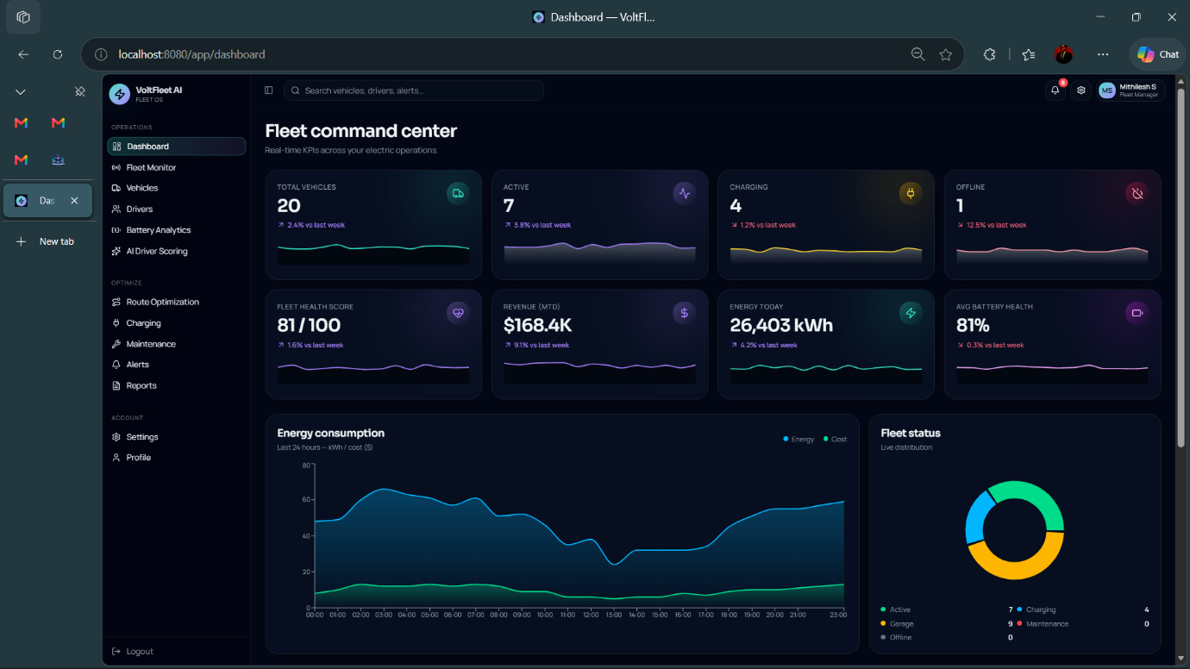
  - FLEET COMMAND CENTER
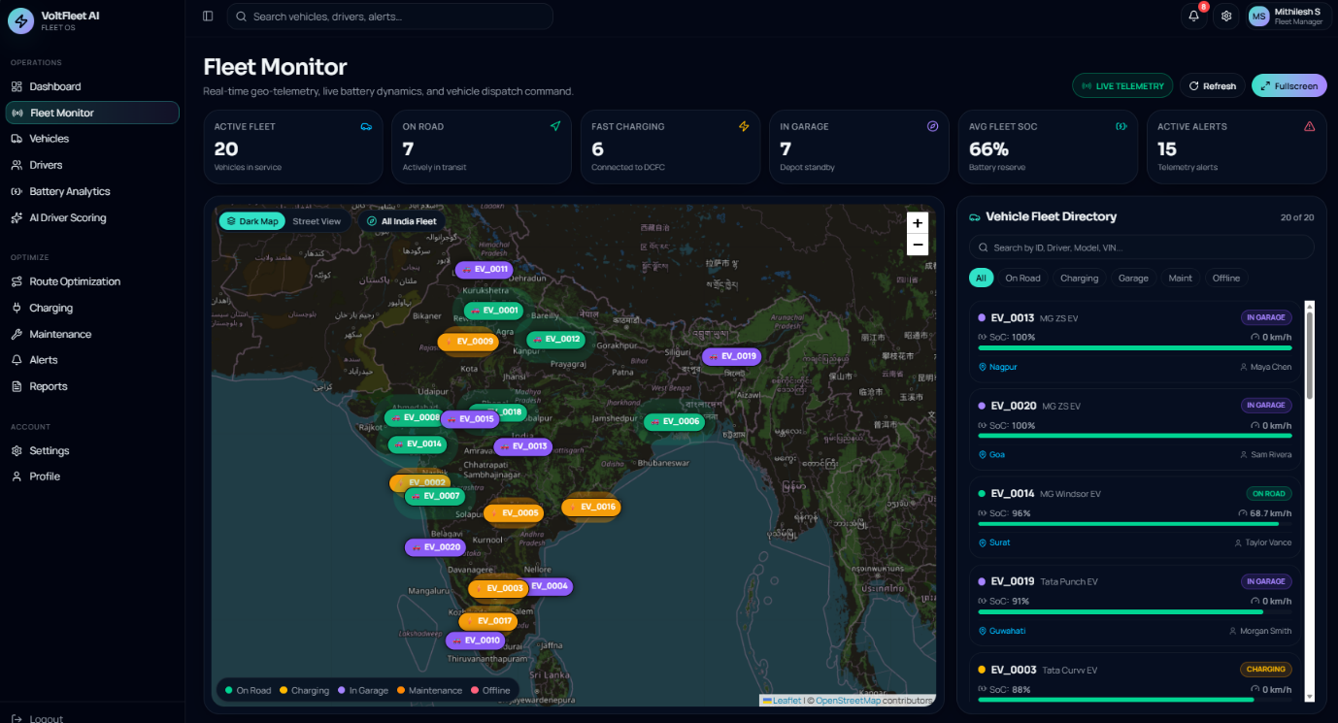
  - FLEET MONITOR

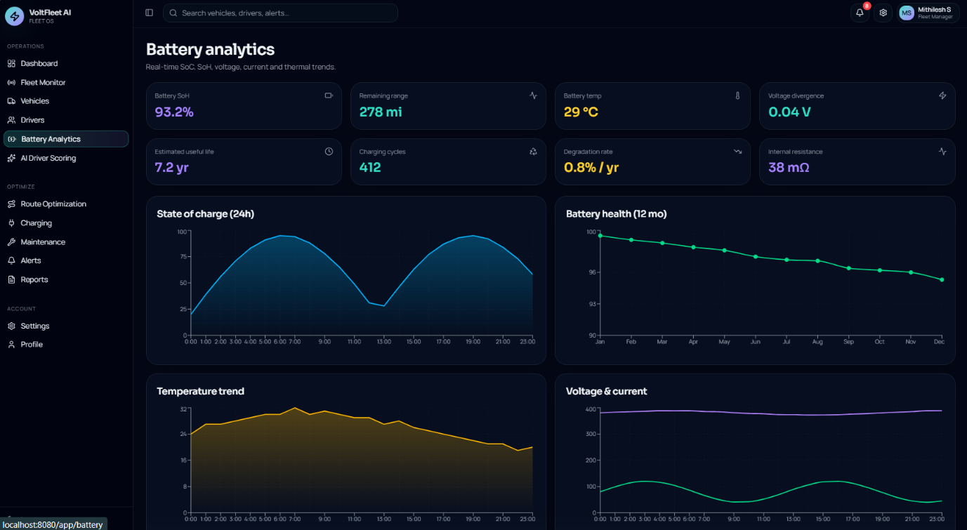
  - BATTERY ANALYSIS
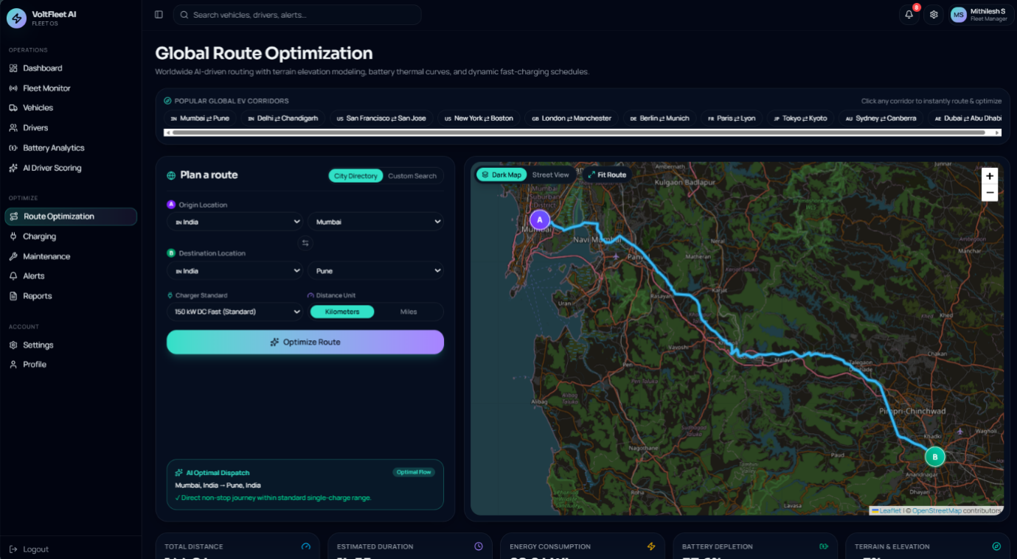
  - ROUTE OPTIMIZATION

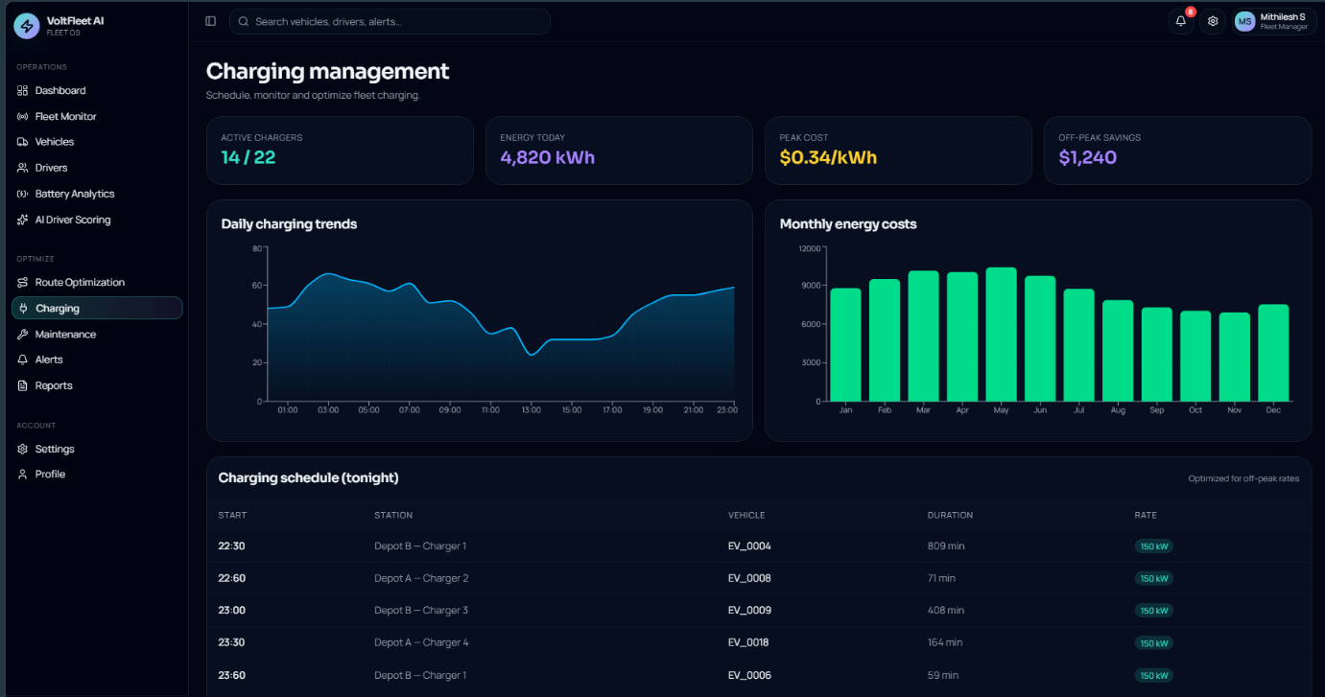
  - CHARGING MANAGEMENT

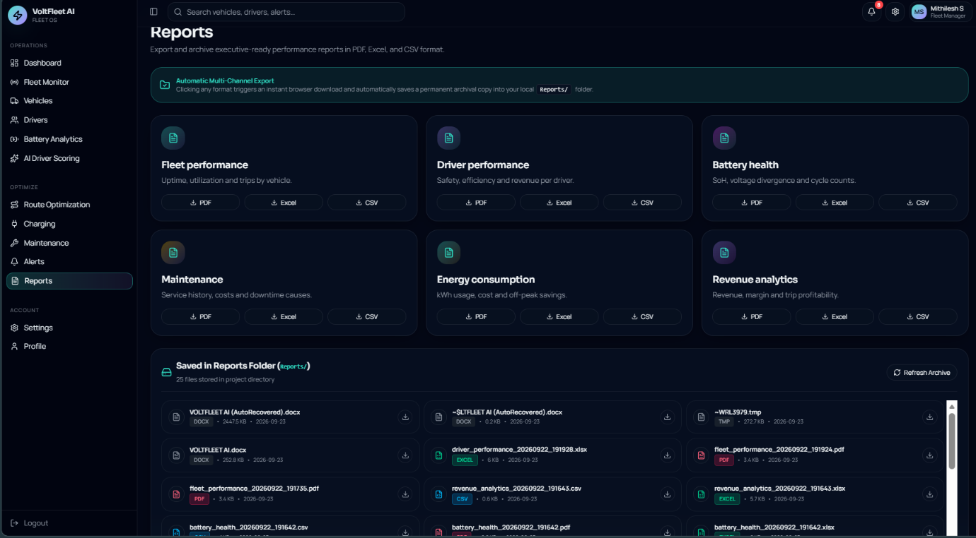
  - REPORTS

